

**Executive Director of Education Services**

**Education Glasgow City Council**

Maureen McKenna City Chambers East Building

40 John Street

Glasgow G1 1JL

Our Ref MMcK/SMcC

Date 29 November 2021

Dear Parent/Carer

**Free School Meals additional payment – Winter Holiday Eligibility**

It is not long until the schools break for the Christmas and New Year school holiday and I wanted to inform parents and carers with P1 – S6 children and young people, who currently meet the eligibility criteria for free school meals, that they will receive an additional one-off Winter holiday payment of £177.50 per child.

This is part of the Scottish Government’s on-going pandemic financial support for our eligible families.

You **do not need** to contact us or make a new application if your family is already in receipt of free school meals and if you have received previous additional holiday payments over the last 20 months.

The money will **automatically** be paid directly into your bank account from 3 December.

In Glasgow, all P1 to P4 pupils receive the universal school meal however, only the families eligible on financial grounds will receive this additional holiday payment and as part of the criteria set down by the Scottish Government.

New applicants who apply before 3 December and meet the eligibility criteria will be paid the £177.50 additional Winter holiday payment and will receive this from 17 December.

New applications received between 3 December – 22 December which meet the eligibility criteria will be paid within two weeks of us receiving the application but please note that this may run into January 2022 due to the council holidays from 25 December – 5 January.

Unfortunately, applications received after 22 December which meet the criteria will only receive free school meals and not the additional Winter holiday payment.

If you think that your family might qualify for free school meals please visit our website to find out more details on the eligibility criteria and fill out an application at <https://www.glasgow.gov.uk/schoolsandlearning>  - there’s also a list of frequently asked questions which may help with any enquiry you have.

Yours sincerely

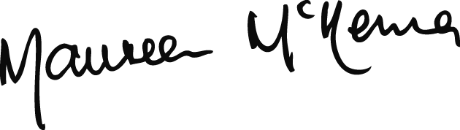

**MAUREEN McKENNA**

Executive Director of Education Services