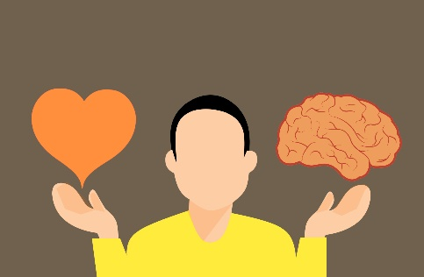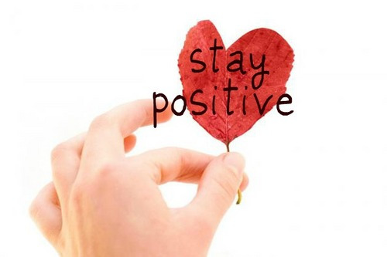**SPINGBURN**

**ACADEMY**

**PHYSICAL**

**EDUCATION**

***BGE Theory/Wellbeing workbook***

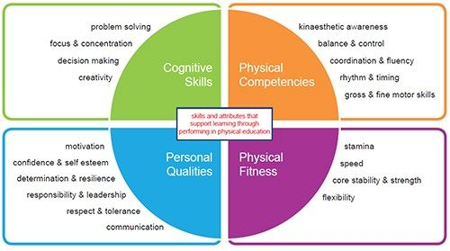During this time, it is important to look after our physical and mental wellbeing. In this workbook there are tasks based on thinking skills, physical skills, physical fitness and personal qualities.

*At the end of this workbook there are resources on how to keep a positive & healthy mindset*

Aim to complete this booklet in your own time (1 task per week)

GOOD LUCK– PE DEPARTMENT

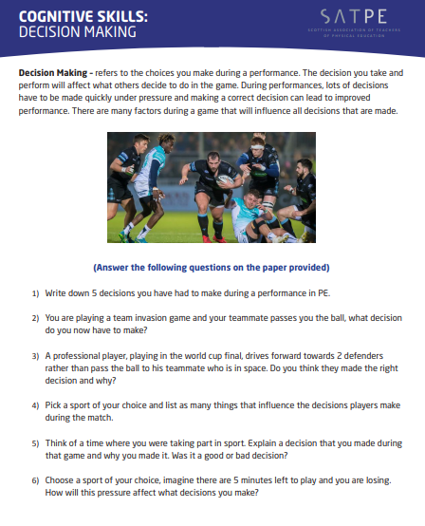

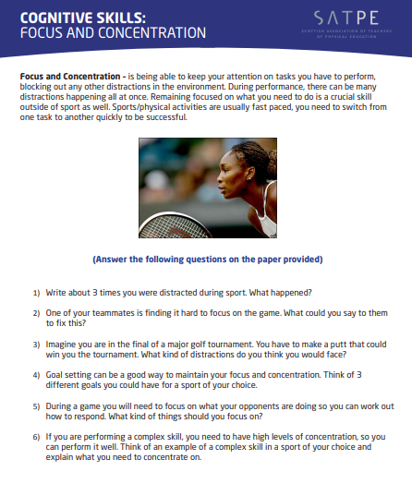

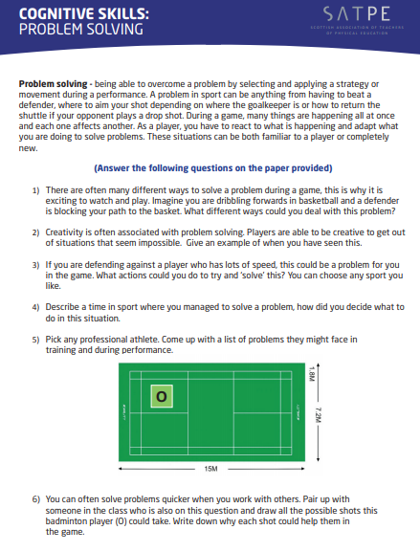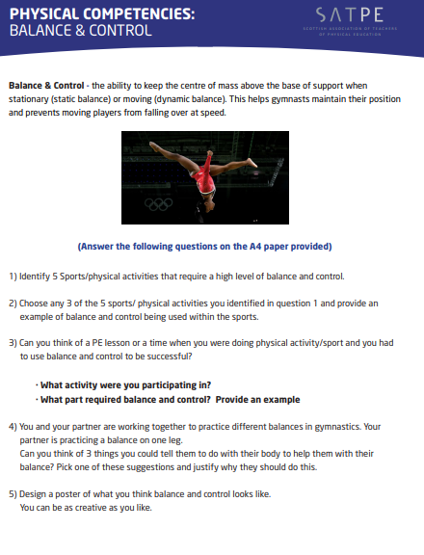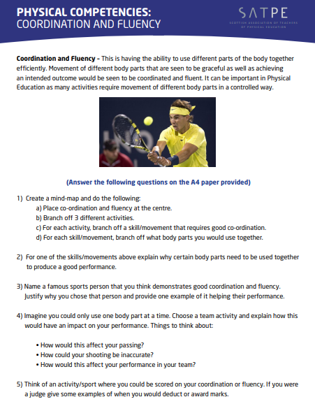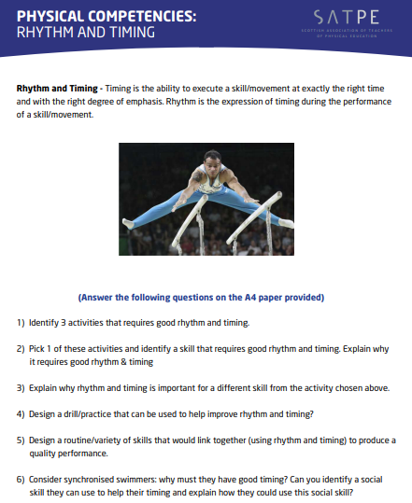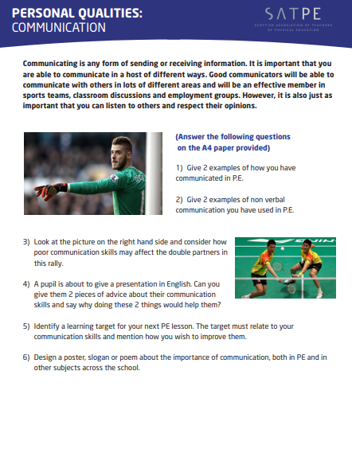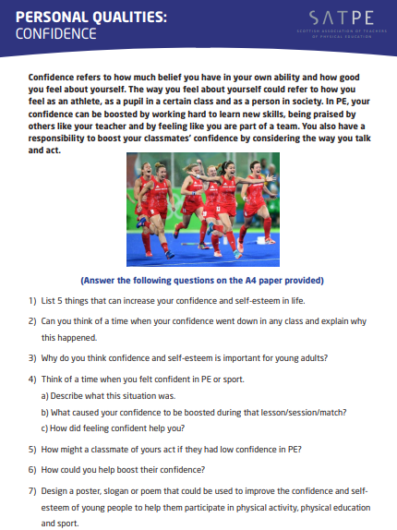

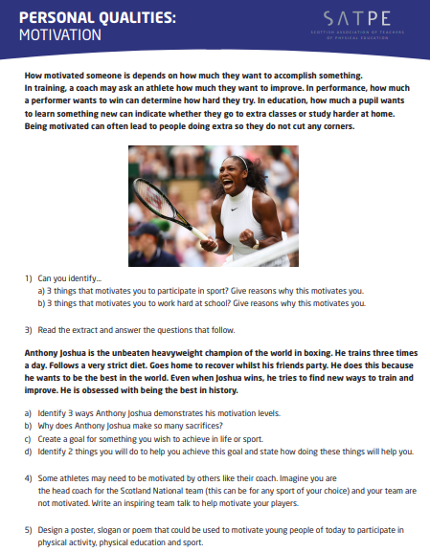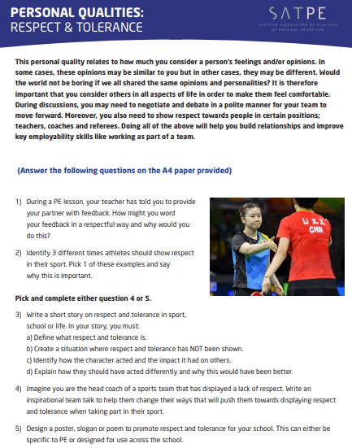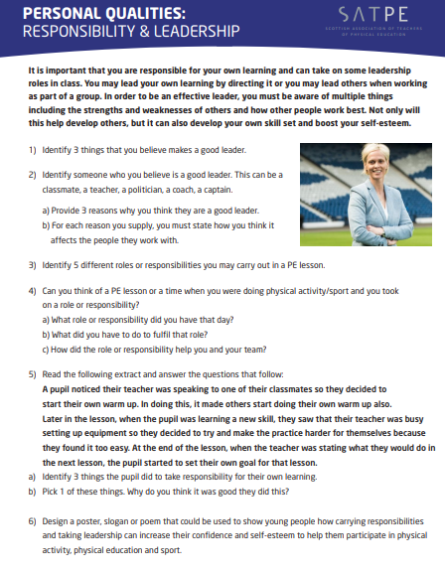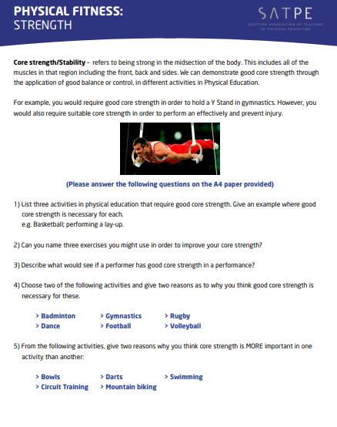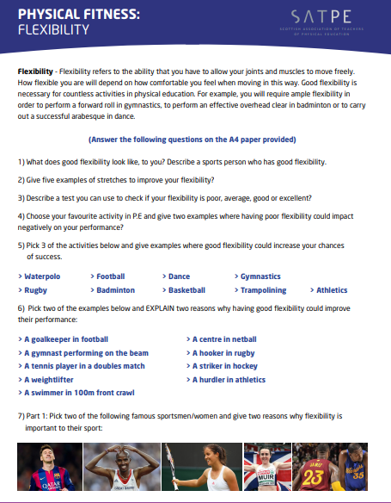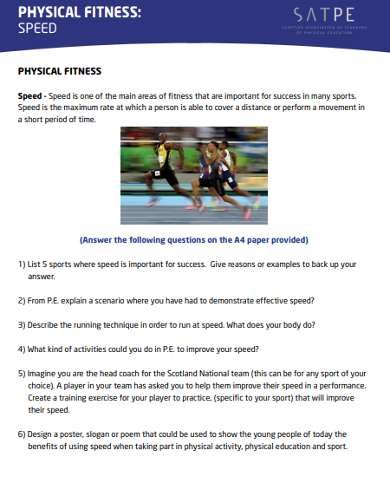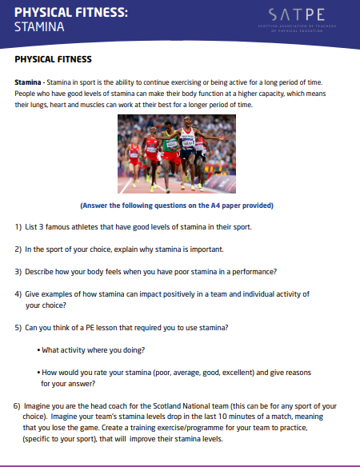

**STAY HEALTHY AND POSITIVE**



[This Photo](https://fr.wiktionary.org/wiki/Fichier:SMirC-thumbsup.svg) by Unknown Author is licensed under [CC BY-SA](https://creativecommons.org/licenses/by-sa/3.0/)

**WE ALL HAVE MENTAL HEALTH** <https://www.youtube.com/watch?v=DxIDKZHW3-E>

**ARE YOU FEELING ANXIOUS?** <https://www.youtube.com/watch?v=ga-MniJxQz8>

**HOW TO STOP NEGATIVE THOUGHTS**- <https://www.youtube.com/watch?v=UAwcCjCzPks>

**TIPS TO STAY MENTALLY HEALTHY** <https://www.youtube.com/watch?v=1RJqgHalbXs>

**RELAX IN 5 MINS** <https://www.youtube.com/watch?v=m3-O7gPsQK0>

**YOGA** <https://www.youtube.com/watch?v=Td6zFtZPkJ4>

**DEEP BREATHING** <https://www.youtube.com/watch?v=PmBYdfv5RSk>

**TO MAKE YOU SMILE** <https://www.youtube.com/watch?v=je4Uw8qUj08>

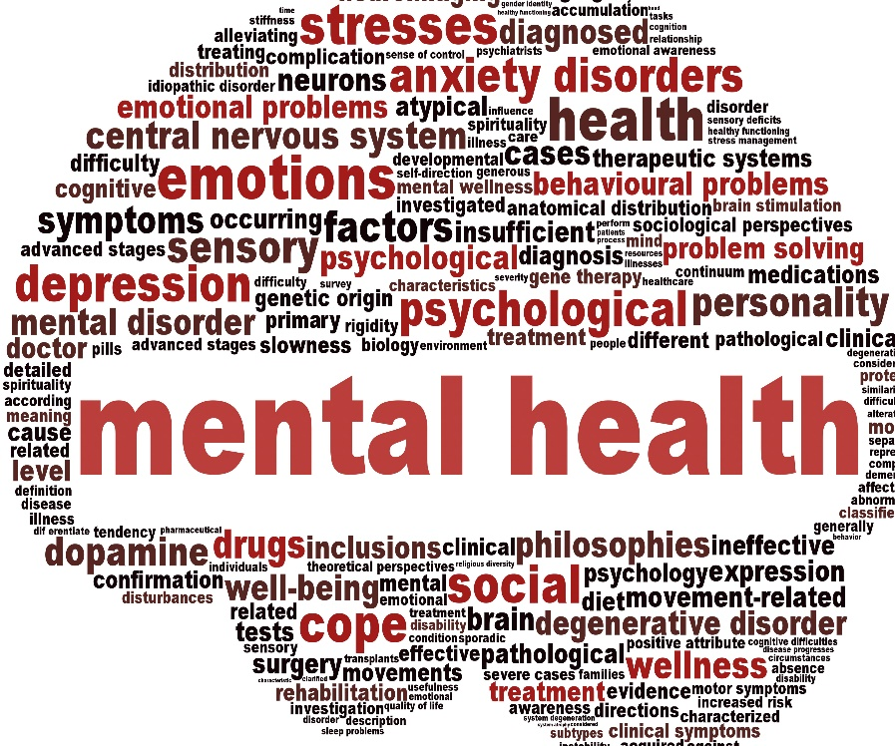

[This Photo](https://moodspectrumreview.wordpress.com/2015/06/13/previous-mental-illness-diagnosis-and-other-health-problems/) by Unknown Author is licensed under [CC BY-NC-ND](https://creativecommons.org/licenses/by-nc-nd/3.0/)