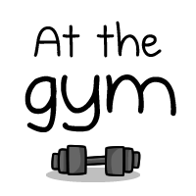
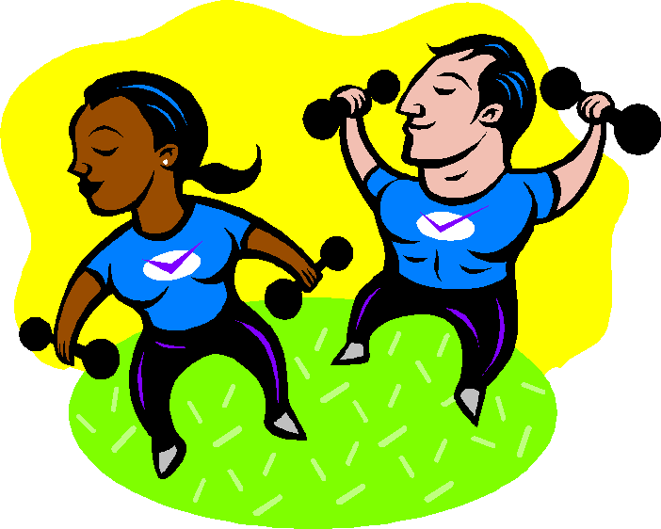
SPRINGBURN
This Photo by Unknown Author is licensed under CC BY-NC-ND
ACADEMY
PHYSICAL
EDUCATION
BGE PRACTICAL WORKBOOK



This Photo by Unknown Author is licensed under CC BY-NC-ND

It is important to stay fit and healthy when you’re at home.
This workbook has a wide range of different workouts that you can complete with 0 equipment.

Your challenge is to complete 2-3 per week.

HAVE FUN – Tweet us pictures/videos of you completing the workouts

FULL BODY WORK OUTS
HIGH INTENSITY INTERVAL TRAINING
20 Minute FAT BURNING Home HIIT Workout | No Equipment https://www.youtube.com/watch?v=J7cpGxqspRU

NEW!! 20 Minute "NO REST" Home Workout | Full Body & Abs

https://www.youtube.com/watch?v=ak9kw5zdyqA

NEW!! 20 Minute FULL BODY Home HIIT | The Body Coach TV

https://www.youtube.com/watch?v=fHfTCd2q-rg

CORE WORK OUTS

5 Minute Abs | The Body Coach

https://www.youtube.com/watch?v=NFihdhNFhdo&list=RDCMUCAxW1XT0iEJo0TYlRfn6rYQ&index=8

8 Minute Abs Workout | The Body Coach

https://www.youtube.com/watch?v=PGyKCMGo_r0&list=RDCMUCAxW1XT0iEJo0TYlRfn6rYQ&index=15

10 Minute Abs Blaster | The Body Coach

https://www.youtube.com/watch?v=L3uqB6FCu5U&list=RDCMUCAxW1XT0iEJo0TYlRfn6rYQ&index=13


MISS SHANKLAND’S SIZZLER
This Photo by Unknown Author is licensed under CC BY-NC-ND
ROUND 1
5 BURPEES
20 RUSSIAN TWISTS
5 CRUNCHES
6LUNGES – EACH LEG
5 SQUAT JUMPS
5 PRESS UPS
5 TRICEPT DIPS
10 SECOND PLANK
REST
ROUND 2
8 BURPEES
30 RUSSIAN TWISTS
10 CRUNCHES
8 LUNGES – EACH LEG
8 SQUAT JUMPS
8 PRESS UPS
8 TRICEPT DIPS
20 SECOND PLANK
REST

ROUND 3
10 BURPEES
40 RUSSIAN TWISTS
15 CRUNCHES
10 LUNGES – EACH LEG
10 SQUAT JUMPS
10 PRESS UPS
10 TRICEPT DIPS
30 SECOND PLANK
REST

THE FINISHER – BURPEES FOR 45 SECONDS
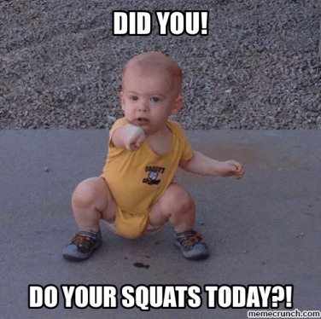
MISS WALKERS’S LEGDAY
This Photo by Unknown Author is licensed under CC BY-ND

- 30 SECOND HEEL FLICKS
10 SECOND REST
- 30 SECOND LUNGES
10 SECOND REST
- 30 SECOND SQUATS
10 SECONDS REST
- 30 SECOND TUCK JUMPS
10 SECONDS REST
- 30 SECOND SIDE LUNGES
10 SECONDS REST
- 30 SECOND STAR JUMPS
10 SECONDS REST
- 30 SECONDS STEP UPS
10 SECONDS REST
- 30 SECONDS SIDE TO SIDE JUMPS
10 SECOND REST
- 30 SECONDS BUNNY HOPS
10 SECONDS REST
- 30 SECOND SPRINTS ON SPOT
COMPLETED ROUND 1 – REST 2 MINS

EASY – 1 ROUND
MEDUIM – 2 ROUNDS
HARD 3 ROUNDS
Mr WILLIAM’S OLYMPIC WORKOUT

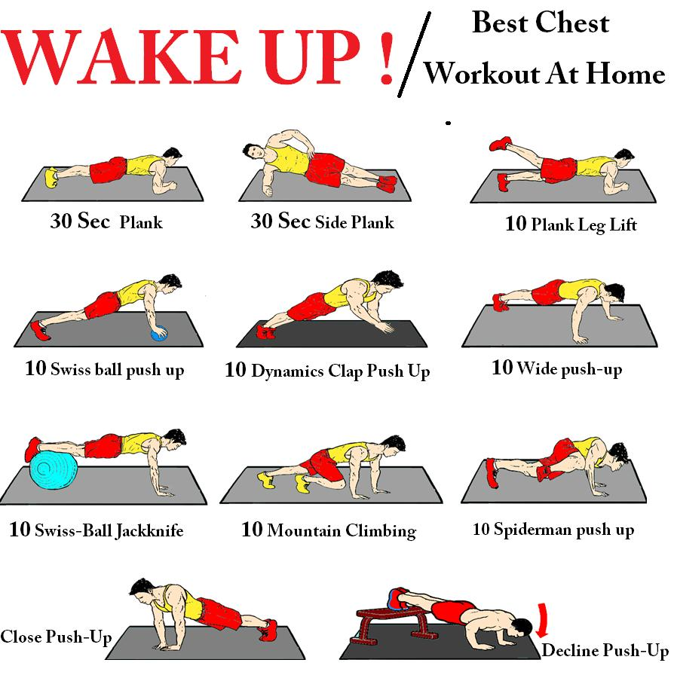
BRONZE – 1 SET
SILVER – 2 SETS
GOLD- 3SETS
MR MCCALL’S MOTIVATIONAL WORKOUT
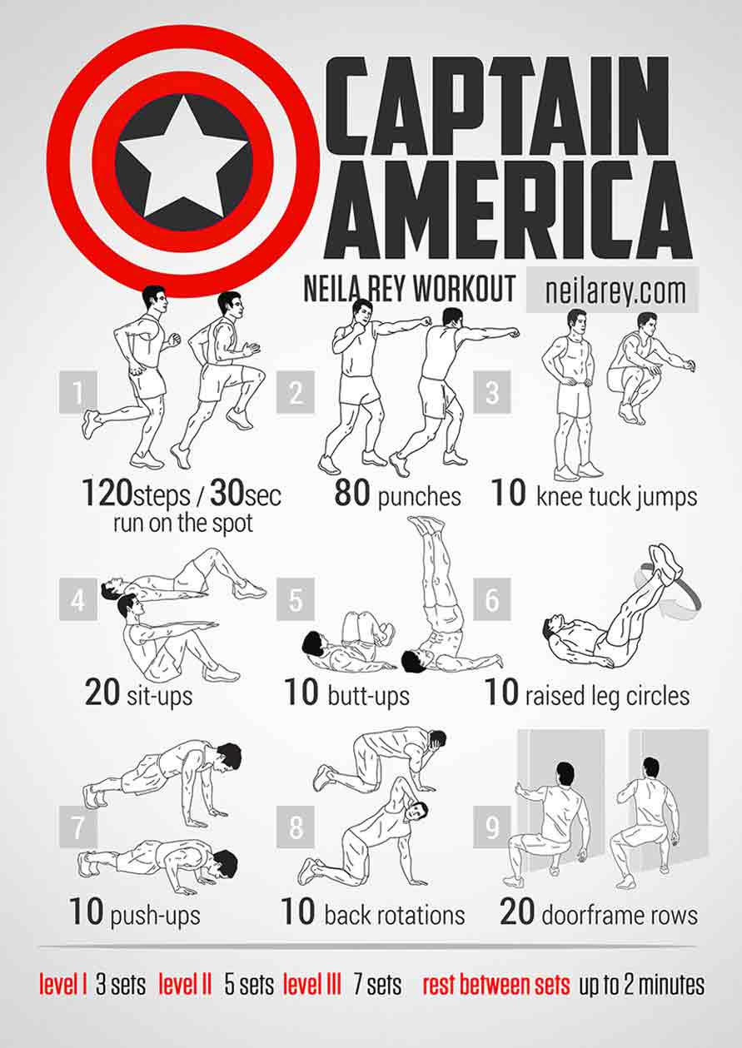

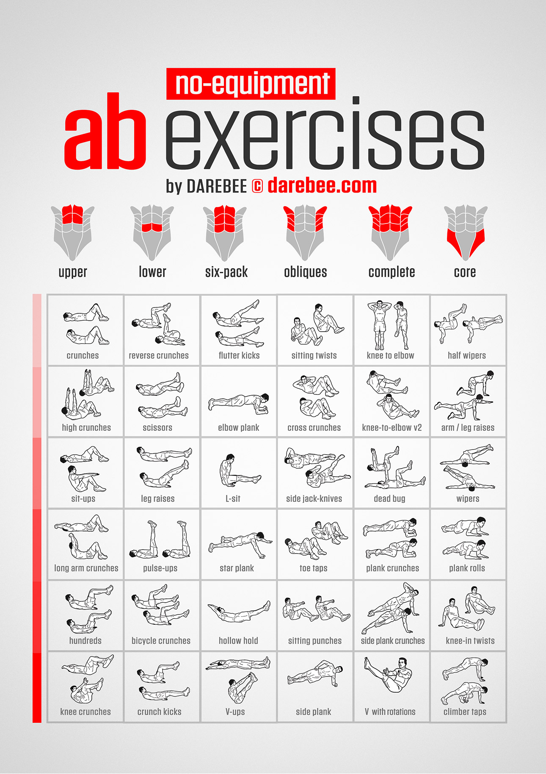
SPRINGBURN CORE CRUNCHER

CHOOSE 8 EXERCISES / 15 REPS OF EACH
1 SET – EASY
2 SETS -MEDIUM
3 SETS -HARD
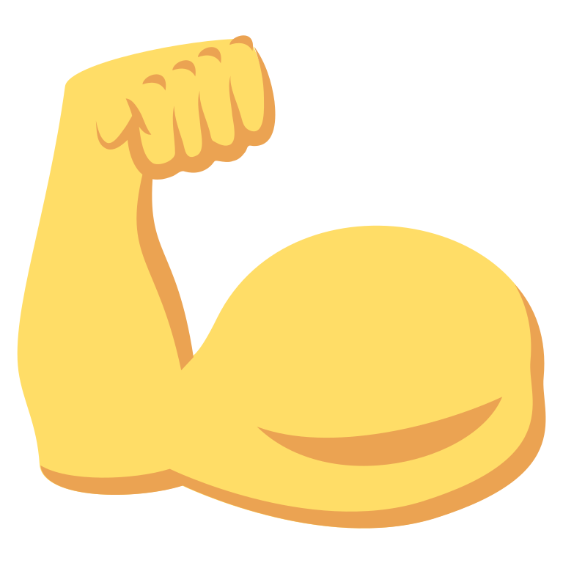
MR RENWICK’S RAPID WORKOUT
This Photo by Unknown Author is licensed under CC BY-SA

- PUSH UPS
15 SECOND REST
- MOUNTAIN CLIMBERS
15 SECOND REST
- BICYCLE CRUNCHES
15 SECOND REST
- HEEL TAPS
15 SECOND REST
- PRESS UPS
15 SECOND REST
- PLANK SHOULDER TAPS
15 SECOND REST
- BEAR CRAWLS
15 SECOND REST
- TRICEPT DIPS

EACH EXERCISE IS FOR 45 SECONDS
CHALLENGE YOURELF TO 2 OR 3 SETS!!

MRS GILMOUR’S KILLER WORKOUT
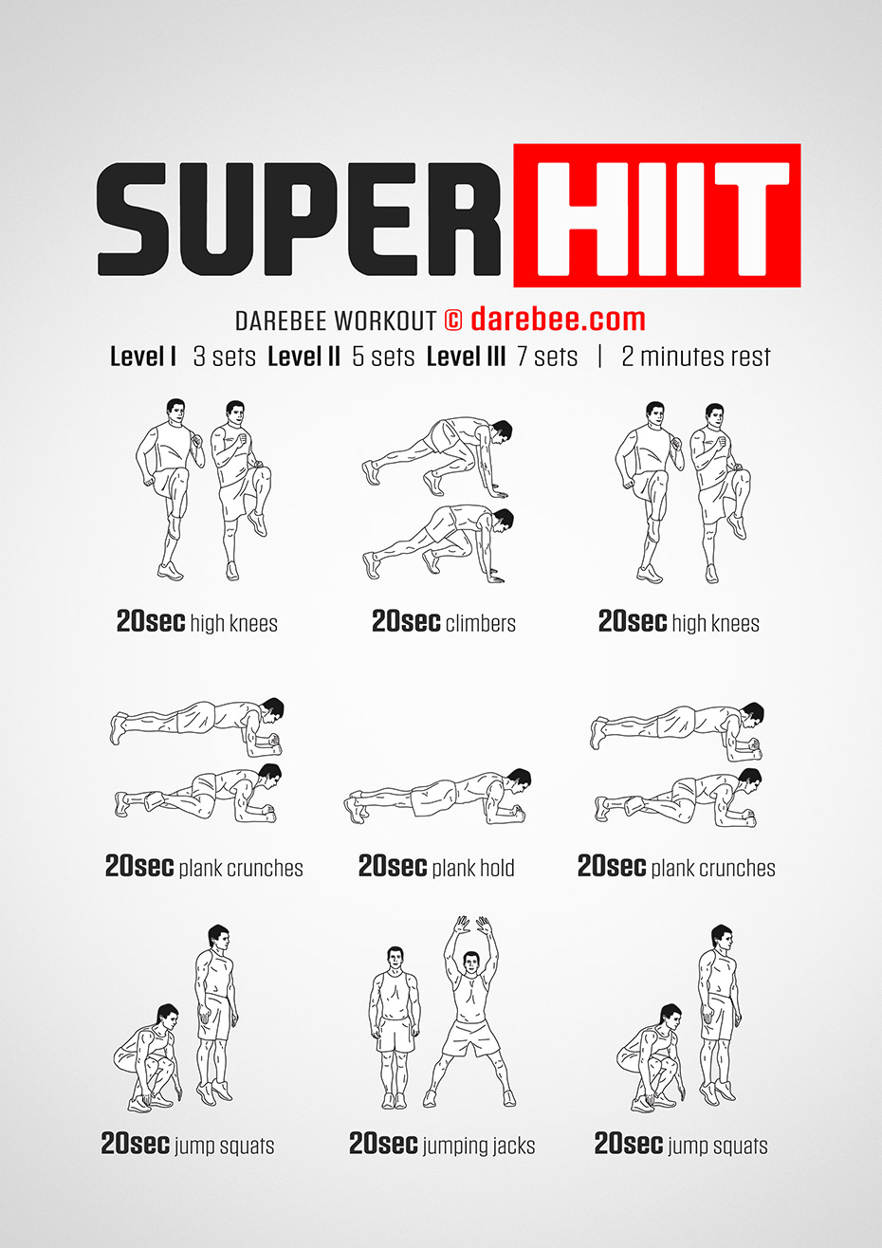

MONSTER WORKOUT
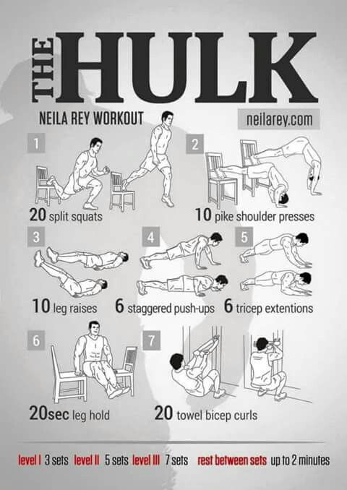

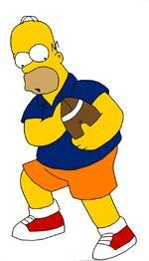
This Photo by Unknown Author is licensed under CC BY-NC-ND
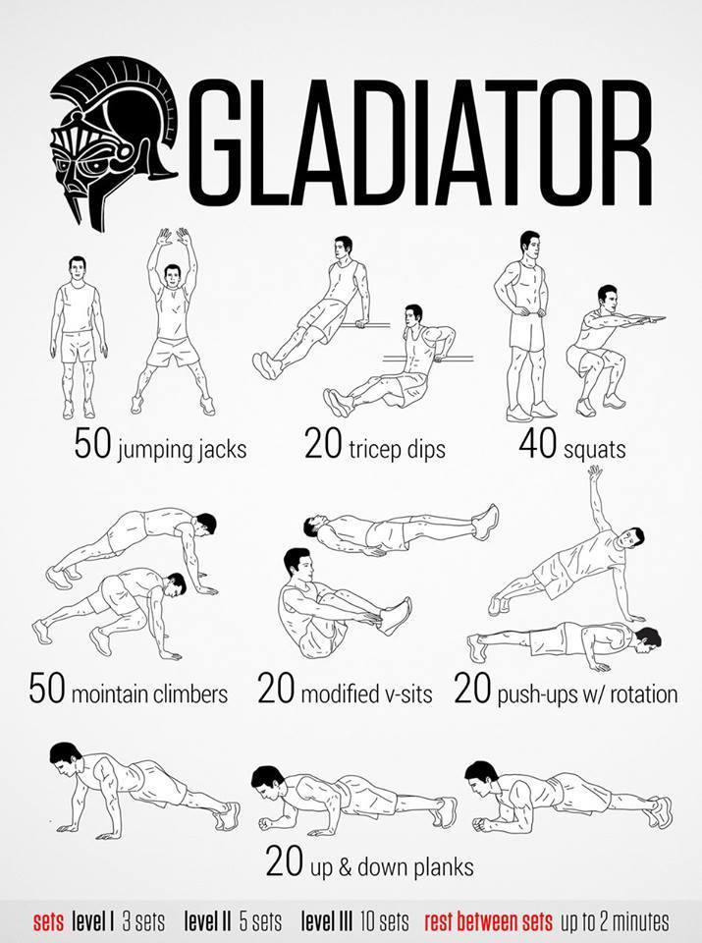

MAKE YOUR OWN WORKOUT
