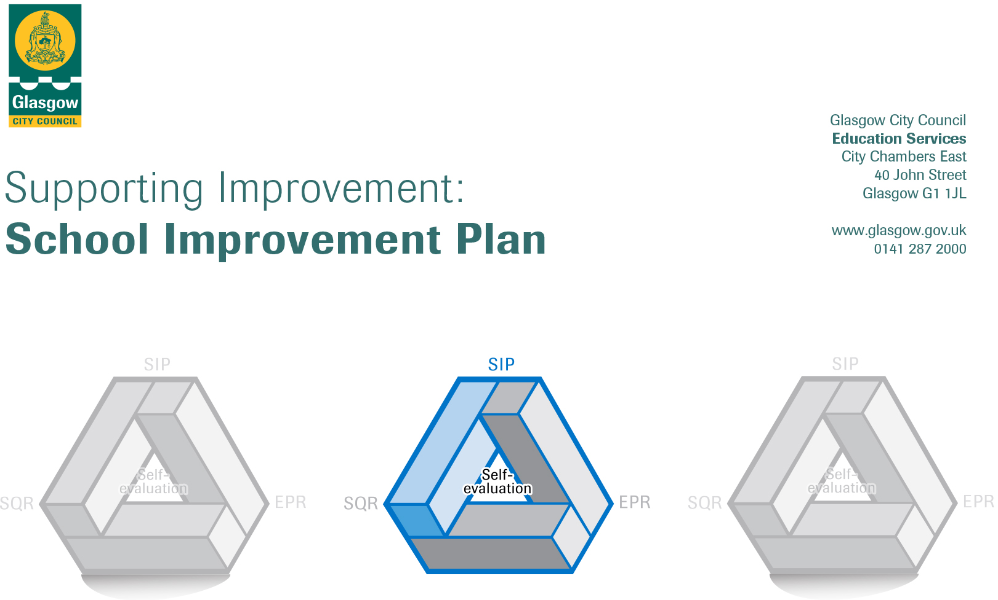

Session: 2019/2020

Establishment |  | Corpus Christi Primary
Head of Establishment |  | Gayle Macdonald
Area/Local Improvement Group |  | North West LIG 2
Head of Service |  | Jim Wilson
Area Education Officer/  Quality Improvement Officer |  | Carolyn Davren

CONTENTS
1. Vision, Values and Aims
2. Summary of Self-Evaluation Process / Priorities for Improvement in the current session
3. Action Planning

Action Plan Summary for Stakeholders

1. Our Vision, Values and Aims
School Vision

In Corpus Christi Primary School ‘We try our best to be the best!’

Our Values

- Respect
- Friendship
- Happiness
- Kindness
- Honesty

Our Aims

- Placing enjoyment and motivation at the heart of our broad, balanced and meaningful curriculum
- Involving pupils in planning innovative and imaginative learning experiences which take account of how children learn best
- Ensuring an inclusive ethos which aims to honour the life, dignity and voice of each person made in the image of God
- Continually developing the environment to ensure our pupils continue to thrive – physically, emotionally, socially, academically and creatively
- Creating a nurturing learning environment where pupils have opportunities to discuss feelings and emotions, take risks, learn from mistakes and grow to understand themselves and those around them
- Developing a whole-school learning community
- Continually developing ways to involve parents, carers and the wider school community in school life
- Being positive and optimistic about the future and what can be achieved

2. Summary of our self-evaluation process.
- Our Quality Assurance calendar provides clear guidelines for our systematic self-evaluation. Staff are involved in reviewing our School Improvement Plan in November and February and they report on curriculum development which has taken place within our Working Groups. In May we work with staff to identify areas for development in the next session. We ensure clear articulation between our PRD/PDP processes for staff which allows us to consider, through professional dialogue, the personal actions required by staff.
- We work closely with staff in reviewing termly Forward Plans and discussing staff evaluations of progress, tracking assessment, undertaking a programme of timetabled class visits, sampling pupil’s work and conducting Learner Conversations.
- We regularly consult with parents/carers on a wide variety of issues which impact on learning and teaching and the ‘Life’ of the school.
- We are continuing to develop new support materials to encourage the use of professional standards in the self-evaluation process and to focus on the impact of continuing professional development.
Strengths identified:
- Self- evaluation is integral to how we work within our community and is an on-going feature of school life.
- Staff work very effectively as a team. There is a strong ethos of sharing practice and of peer support. Staff are becoming more outward looking with regards to sharing good practice and moderating across a level.
- The life skills approach which has been adapted for EAL learners has been very successful. It has provided them with opportunities to develop their acquisition of the English language within a real life context.
- There is evidence that children and young people are confidently engaged in reviewing and taking responsibility for their own learning and gaining confidence in their abilities.
- Positive partnerships and working with agencies across the learning, local and wider community.
- Parental engagement through ESOL classes, parent support group (Parents’ CCAN) and the EAL learning opportunities with parents/carers.
- School and wider community achievement is recognised, valued and celebrated.
- The school has a positive reputation in the local community, were strong partnerships with parents and the wider community are valued.
- Effective approaches to Digital Learning and Science, Engineering and Technologies.
Priorities for development:

- Numeracy and Mathematics
- Making Thinking Visible
- Wellbeing and Inclusion

3. Action Planning

No. | Quality Indicator | Priority
1 | 2.2 | Numeracy and Mathematics  Introduce and embed Glasgow Counts approaches in establishment.

Tasks to achieve priority | Timescale  and checkpoints | Evidence of Impact > (data, observation, views)
Assessment of pupils from P1-P7  Write draft outcomes for HGIOP  Attend core Glasgow Counts training  CLPL whole team sessions  Identify required resources | August and May  August  August-June  September -June  August -June | MALT Assessments, learning conversations, video clips, assessment grid used to establish baseline levels of pupils and to identify progress over the year.  From MALT assessments use data to clarify areas to develop and target for HGIOP.  Begin to introduce Glasgow Counts approaches in establishment. Begin to introduce uniform language and scaffold displays across establishment. Impact will be measured through classroom observations, video clips, wall displays and learning conversations.  Monthly collegiate sessions to up skill staff on Glasgow Counts approaches. Before and after questionnaires and evaluations to assess impact on teacher’s knowledge and abilities.  Take inventory of existing resources available in each class in establishment. From inventory data gathered and following each Glasgow Counts training input buy in any resources required which are currently unavailable in establishment.
Identify target groups  Staff targeted interventions. | September  October | Use baseline assessments, learner conversations, video clips and assessment grids to establish pupils who required additional support.  From assessment data begin working with groups with the objective of raising attainment in pupils who require additional support.
Team Teaching/Modelling Programme  Glasgow Counts check points  POLLI visits | October -June  October  January  April  February and March | From Glasgow Counts inputs begin to model approaches with teachers in class. Use video clips, surveys, questionnaires to assess before and after impact on children, teachers and support staff  PT to meet with Glasgow Counts supporter to identify progress made so far, challenges and areas to develop going forward.  PT to meet with Glasgow Counts supporter to analyse impact on target group. Peer review to take place. Determine focus areas for POLLI, CLOL and SLT observations.  Challenge visit to determine how embedded Glasgow Counts approaches are in establishment. PT to meet with Glasgow Counts supporter to identify progress made so far, challenges and areas to develop going forward.  Classroom visits to observe impact of Glasgow Counts approaches in class. Impact measured through observations, learning conversations, video clips, staff feedback sheets
Collect and analyse data | December and May | Review activities and evidence up to this point.  Continue or re-evaluate goals through data gathered, classroom observations, POLLI feedback and learner conversations.
Complete HGIOP  Next steps | May  May | Collate all evidence gathered from baseline and final assessments, learner conversations, video clips and assessment grids.  Analyse HGIOP with HT.DHT. Analyse all data gathered from evidence sources. Identify areas of strength and areas to develop for next year’s SIP.

Staff leading on this priority – including partners | Resources and staff development
Gayle MacDonald HT  Sharron McEwan DHT  Nicola Farrell DHT  Chris Gallagher PT | - New and existing maths resources related to Glasgow Counts approaches.  - MALT assessments  - Staff surveys and questionnaires  - Ipads for recording video clips and learning conversations  - All teaching staff to participate during collegiate sessions.  - All support staff to participate during CLPL sessions.

No. | Quality Indicator | Priority
2 | 2.3  3.2 | Learning and engagement  Quality of teaching  Effective use of assessment  Attainment over time  Overall quality of learner’s achievement  Equity for all learners

Tasks to achieve priority | Timescales and  checkpoints | Evidence of Impact > (data, observation, views)
Increase practitioner knowledge and confidence in teaching thinking skills across the curriculum, leading to improved learner experiences. This will be achieved by: | - Regular CPD provided for staff (August and October Inset and three collegiate sessions)  - Learning conversations  - Quality Assurance - Teacher observations/ POLLI  - Modelling of MTV approaches throughout the session  - Forward planning and tracking meetings. | - Initial baseline and final survey of teachers using glow surveys to measure their knowledge and confidence in teaching of Making Thinking Visible strategies  - Initial baseline and final survey of a group of children to measure if they have experienced improved learning experiences  - Evidence through learning conversations with pupils, teacher observations and POLLI’s.  - Learning pathways evidence thinking skills being incorporated into the planning, learning and teaching across the curriculum.  - Professional dialogue during planning and tracking meetings referencing MTV strategies.
Whole School CPD sessions | - Five sessions (Inset and collegiate)  - Evaluation after each session | - Session One – Thinking Routines – Introducing and exploring ideas  - Session Two – Thinking Routines – Synthesising and organising ideas  - Session Three – Thinking Routines – Digging Deeper into ideas  - Session Four – How visible is our thinking now? How do we know?  - Session Five – Changing the culture – A place where thinking is valued, visible and actively promoted.
Forward plans and pathways should indicate explicit teaching of Making Thinking Visible (MTV) strategies across the curricululm | - Planning meetings  - Evaluate each term | - Learning Pathways evidence Making Thinking Visible strategies being planned across the curriculum from P1-7  - Creativity and a variety of strategies such as ‘I See, I Think, I Wonder’, ‘Zoom in, zoom out’, ‘Compass Points’, ‘Colour, Symbol, Image’ and ‘Sentence, Phrase, Word’ evident in planning and delivery.
Practitioners making use of moderation and reflection to develop their learning and teaching in relation to making Thinking Visible | - On-going  - Termly checkpoints | - Staff CPD sessions – Inset and collegiate  - Join planning  - Planning and tracking meetings  - Classroom displays and observations – evidence of Thinking Skills being used in daily practice

Staff leading on this priority – including partners | Resources and staff development
Stacey Donnelly PT  Kirsty Shannon  Louise White PT | Staff development through CPD at collegiate meetings and Inset days, team teaching and modelling.  Making Thinking Visible textbook, booklets, DVD and resources  Post its, large paper and pens/pencils

No. | Quality Indicator | Priority
3 |  | To further embed ASN and nurturing approaches across the establishment.

Tasks to achieve priority | Timescale  and checkpoints | Evidence of Impact > (data, observation, views)
Assessment of staff abilities and confidence in understanding the developmental needs of children. | September | Baseline survey of staff’s understanding of the developmental progress of children. This will be measured again in May to establish the impact of further embedding nurturing approaches and to plan for next year’s SIP
Staff training on how to create a Wellbeing Assessment Plan (WAP) | September | Baseline survey of staff’s understanding of how to create these in collaboration with parents, SLT and pupil. This will be measured again in May to establish the impact of further embedding approaches and to plan for next year’s SIP  Development of staff’s ability to create specific, measurable, achievable, realistic, time evaluated (SMART) targets in collaboration with pupils, parents and SLT
Observation of good practice in other establishments within learning community through trio visits. | September | SLT member will visit other establishment and share ideas and good practice on return with SLT and staff.
Staff to create WAPs for pupils at their stage | October | Staff will work in collaboration with SLT, parents and pupils to create WAP’s for pupils. Staff baseline survey at beginning and end of the year will measure impact of training.
Staff training on how to use one of: Teaching Talking Toolkit/Boxall Profile/Strengths and Difficulties Questionnaire/ Glasgow Motivation and Wellbeing Profile | November | Staff baseline survey at beginning and end of the year will measure impact of training.  Conversations with staff about impact on practice.
Assessment of pupils from P1-P7 | November | Staff begin to use one of: Teaching Talking Toolkit/Boxall Profile/Strengths and Difficulties Questionnaire/ Glasgow Motivation and Wellbeing Profile in their practice for identifying pupils who require additional support  Impact will be measured from baseline score in November and second assessment in March.
Collect and analyse data | December | Review activities and evidence up to this point.  Continue or re-evaluate goals through video clips, data gathered, classroom observations, staff feedback and learner conversations.
SLT Observations of pupils | December | From staff referrals of pupils who require additional support SLT will observe pupils in classroom setting to identify challenges pupils face and to provide strategies for support.
Observation of good practice in other establishments within learning community through trio visits. | January | SLT member will visit other establishment and share ideas and good practice on return with SLT and staff.
Follow up training for staff on how to create a WAP and how to use one of Teaching Talking Toolkit/Boxall Profile/Strengths and Difficulties Questionnaire/ Glasgow Motivation and Wellbeing to measure impact of interventions on pupils | February  Inservice | Through staff presentation, surveys, data and spoken views provide additional support and areas to improve in creating these plans and using these support tools.
Assessment of pupils from P1-P7 | March | Staff to use one of Teaching Talking Toolkit/Boxall Profile/Strengths and Difficulties Questionnaire/ Glasgow Motivation and Wellbeing to measure impact of interventions on pupils.
SLT Observations of pupils | March | SLT will observe pupils in classroom setting to measure impact of strategies provided to support learners.  SLT will use one of: Teaching Talking Toolkit/Boxall Profile/Strengths and Difficulties Questionnaire/ Glasgow Motivation and Wellbeing Profile Wellbeing Profile to measure impact of intervention and next steps for learners.
Observation of good practice in other establishments within learning community through trio visit. | April | SLT member will visit other establishment and share ideas and good practice on return with SLT and staff.
Collect and analyse data | May | Review activities and evidence up to this point.  Continue or re-evaluate goals through video clips, data gathered, classroom observations, staff feedback and learner conversations.
Next steps | May | Analyse progress with HT, DHTs and PTs. Analyse all data gathered from evidence sources. Identify areas of strength and areas to develop for next year’s SIP.

Staff leading on this priority – including partners | Resources and staff development
Gayle McDonald HT  Nicola Farrell DHT  Sharon McMillan DHT  Chris Gallagher PT  Lauren Agnew PT  Vicky Kytzia PT | Staff development through CPD at collegiate meetings and Inset days.  One of: Teaching Talking Toolkit/Boxall Profile/Strengths and Difficulties Questionnaire/ Glasgow Motivation and Wellbeing Profile  DVD and resources  Ipads and hall projector  Post its, large paper and pens/pencils

