Community Involvement

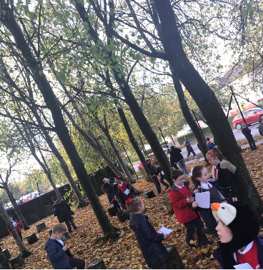
CORPUS CHRISTI PRIMARY
OUTDOOR LEARNING
SCHOOL

SCHOOL HANDBOOK
2021– 2022

OUR COMMUNITY
“We Try Our Best To Be The Best”

CORPUS CHRISTI PRIMARY SCHOOL
179 Pikeman Road, Knightswood, Glasgow G13 3BH

Dear Parent / Carer

On behalf of the staff of Corpus Christi Primary I would like to welcome you and your child to our school community.

We work very closely as a team ensuring a caring environment where your child will feel valued and will develop all of their skills and talents.

We provide a range of activities throughout the school year which give parents and carers the opportunity to meet and work closely with us and our Parish community. We really enjoy being able to showcase our pupil’s wonderful achievements to you.

The purpose of this handbook is to give you as much information about our school as we can.

Should you require any additional information please do not hesitate to contact me.

I look forward to working with you in the years ahead.

Yours faithfully

Gayle Macdoanald

Head Teacher

SCHOOL VISION and VALUES
In Corpus Christi Primary School we will provide a welcoming and friendly environment, which celebrates the diversity of our community.

We are a nurturing school where everyone feels safe, happy and valued and all children are supported to reach their full potential. This is achieved through working together with children, their families and the community, based on a shared sense of direction and a commitment to our Catholic faith.

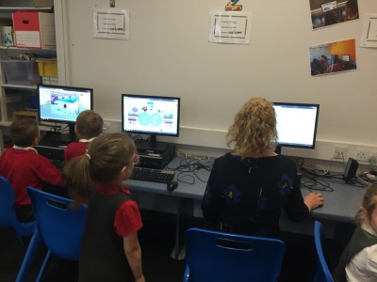
- Respect.
- Equality and Inclusion.
- Friendship.
- Pride.
- Nurturing and Caring.
- Honesty.
- Healthy.
ICT LESSON

SCHOOL INFORMATION

You can cut out the following information and have it on your fridge, purse and work desk etc for ease of finding the numbers required.
CORPUS CHRISTI PRIMARY SCHOOL CONTACT DETAILS:

179 Pikeman Road
Knightswood
GLASGOW G13 3BH

Telephone: 0141 954 5380
email: headteacher@corpuschristi-pri.glasgow.sch.uk
Absence Line: 0141 287 0039
Glasgow City Council: www.glasgow-pri.glasgow.sch.uk

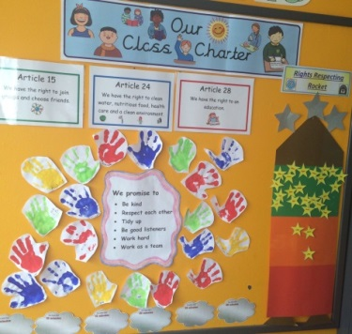
BACKGROUND INFORMATION

- Co-educational school.
- Denominational.
- Stages Taught: P1 – P7.
- Current Role: 394
- Capacity: 449
Class Charter

SCHOOL STAFF

A full list is available on the school website and parents will be updated on any changes as required.

SENIOR LEADERSHIP TEAM

Headteacher | Miss Gayle Macdonald
Depute Headteacher P1 – P3 | Mrs Nicola Rooney
Depute Headteacher P4 – P7 | Miss Sharron McMillan

ENROLMENT

Registration of Primary 1 children takes place in November and is advertised widely in local press etc. Prospective parents are welcome to visit the school and should contact the school office.

Families living out with the catchment area are welcome to make a placing request to attend Corpus Christi Primary School but must enrol their child at their local school as a first step. Further information is available using the following link: http://www.glasgow.gove.uk/index.aspx?articleid=18426

ORGANISATION OF CLASSES

The following guidelines set by Scottish Government apply.
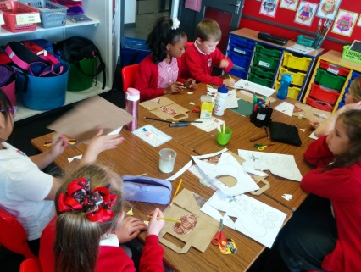

Primary 1 | Maximum 25 | Primary 4 – 7 | Maximum 33
Primary 2 – 3 | Maximum 30 | Composite Class | Maximum 25

Composite classes have pupils from more than one stage.

THE SCHOOL DAY
P1 -3 School Day | 08.50 – 14.50
Morning Interval | 10.15 – 10.30
Lunch | 11.45 – 12.30
P4 – P7 School Day | 09.10 – 15.10
Interval | 10.30 – 10.45
Lunch | 12.30 – 13.10

One of Our Lively Dance Sessions
SCHOOL HOLIDAYS 2021-2022

Details of holiday dates are available on the Glasgow City
Council website: http://www.glasgow.gov.uk/index.aspx?articleid=17024

PUPIL ABSENCE

Within Glasgow Primary School good attendance is encouraged at all times and children rewards accordingly. Parents are asked to advise if their son or daughter is going to be absent. This should be done as early as possible on the first day of absence. If the young person is going to be absent for some time, it would be helpful to know at the earliest opportunity. The school uses daily text messaging to inform parents and cares of absence if no contact is made. All unexplained absence if investigated by the school and appropriate action taken. All calls must be made to the:

PUPIL ABSENCE REPORTING LINE:

0141 287 0039
08.00 – 15.30 Monday - Friday

MEDICAL and HEALTHCARE
The school nurse visits at various times during the year for routine health checks, vaccinations and medical examinations. Parents are kept informed by letter.

If a child becomes ill during the course of the school day, he/she may require to be sent home. Please ensure that you keep the school informed of ALL contact details.

Parents should inform the school of any medical requirements relating to their child. If a child requires medication during the school day, parents must complete the appropriate medical form. This is available on request from the school office.

EMERGENCIES
We make every effort to maintain a full educational service, but on some occasions circumstances arise which lead to disruption. Schools may be affected by, for example, severe weather, temporary interruption of transport, power failures or difficulties of fuel supply.

In such cases, we shall do all we can to let you know about the details of our closure or re-opening by using letters, texts and the local media etc.

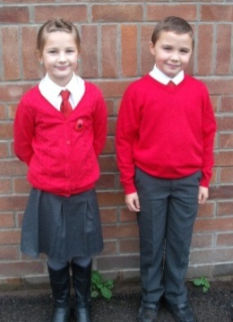
SCHOOL UNIFORM

The school uniform is:

- White shirt
- Red jumper/cardigan
- School tie (red)
Our Uniform
- Grey trousers.
- Grey shirt.
- Black school shoes.

Sweatshirts, cardigans, polo shirts and ties with the school log are available for purchase at Trutex Store, 35B Argyle St, Glasgow G2 8AH. Our uniform was agreed in consultation with pupils and parents. It is expected that all children attending Corpus Christi Primary School will adhere to this dress code.

PE KIT
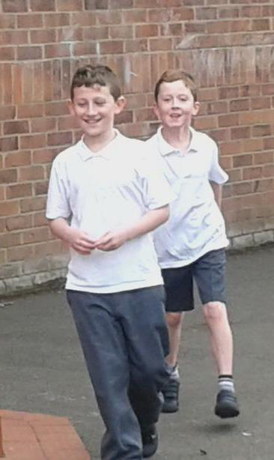
It is important that pupils come prepared to learn and for PE this requires appropriate clothing. All jewellery should be removed. Pupils who are not participating in PE must have a note or a medical certificate. Pupils who are unable to participate in practical PE should still bring their kit to allow them to assist in the lesson by refereeing, keeping scores or assisting with the distribution of equipment. This ensures that they are still able to take part in some way in the work of the class and do not miss out on the knowledge and understanding of the course.
PE
There are forms of dress that are unacceptable in school, such as items of clothing which:

- Potentially encourage factions (such as football colours).
- Could cause offence (such as anti-religious symbolism or political slogans).
- Could cause health and safety difficulties (such as loose fitting clothing, jewellery).
- Could cause damage to flooring.
- Carry advertising particularly for alcohol or tobacco.
- Could be used to inflict damage on other pupils.

CLOTHING AND FOOTWEAR GRANTS

Parents / Carers receiving Income Support, Job Seekers Allowance (income based), Working Tax Credit (with a total annual income of less that £15,050*). Housing Benefit or Council Tax Benefit will normally be entitled to monetary grants for footwear and clothing for their children. Information and application forms may be obtained from schools and at www.glasgow.gov.uk/index.aspx?articleid=17885

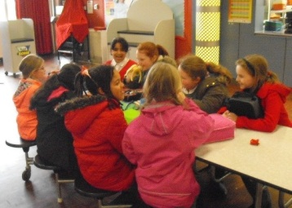
SCHOOL MEALS
Our school provides a lunch service which offers a variety of meals and snacks. Special diets for children with medial requirements can be provided. Please inform the Head Teacher.

Children who prefer to bring packed lunches are accommodated in the dining hall.

Children and young people or parents / carers receiving Income Support, income based Job Seekers Allowance, Working Tax Credit (where income is less than £6,420), Child Tax Credit only (where income is less than £15,910*) and income related Employment and Support Allowance are entitled to a free midday meal. Information and application forms for free school meals may be obtained at: www.glasgow.gov.uk/index.aspx?articleid=17885
Enjoying Our Lunch Together
TRANSPORT

The education authority has a policy of providing free transport to all pupils who live out with a certain radius from their local school by the recognised shortest walking route. This policy is more generous than the law requires. This means that the provision of transport could be reviewed at any time. Parents / Carers who consider they are eligible should obtain an application form from www.glasgow.gov.uk/index.aspx?articleid=17882

TRANSFER FROM PRIMARY TO SECONDARY SCHOOL
Children and young people normally transfer between the ages of 11½ and 12½ so that they will have the opportunity to complete at least 4 years of secondary education. Parents and carers will be informed of the school arrangements no later than December of Primary 7.

Children from our school normally transfer to:

St Thomas Aquinas Secondary School
112 Mitre Road
Glasgow G14 9PP
email: headteacher@glasgow-sec.glasgow.sch.uk
www.glasgow-sec.glasgow.sch.uk

St Thomas Aquinas staff work with our pupils from Primary 6 onward to prepare them for the transfer to secondary school.

COMMUNICATION WITH PARENTS
At Corpus Christi Primary School we use a variety of ways in keeping in touch.

OPEN DOOR POLICY - Our leadership team is available for all parents and carers at any time if they are available. Please either pop into the school office or phone for an appointment.

CLASS DIARIES - will let parents know what homework has been set and is also used to communicate between class teachers and parents.

NEWSLETTERS - will be sent out on a regular basis to keep parents informed about the work of our children and the school.

LETTERS - further information which requires a response may be sent out in letter form.

SCHOOL WEBSITE / TWITTER – will contain a great deal of information about our school. It is good to check these regularly.

TEXT MESSAGING – you may also receive text reminders about events / school closures etc.

MEETINGS – Parents and cares are welcome in the school to discuss any aspect of their child’s development and progress. To avoid disappointment, it is advisable to make an appointment.
There are various opportunities throughout the year when parents can discuss their child’s progress with the class teacher and view the child’s work.

Parents and Carers are welcome at other events throughout the school year, eg workshops, information evenings, class performances, religious and other assemblies. The school newsletter and website will keep you informed.

EMERGENCY CONTACT INFORMATION
At the start of each school session, parents will be issued with the annual data check form. Please ensure that this is completed and returned to the school. It is also important that you let us know if there are changes to your contact number(s) or to those of your emergency contacts throughout the year.

PRIVACY STATEMENT AND DATA PROTECTION

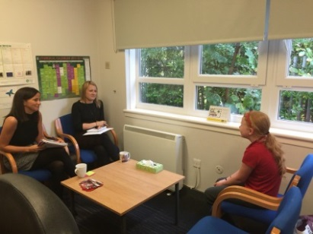
USE OF INFORMATION ABOUT CHILDREN AND PARENTS / CARERS
Confident Individuals
We collect information about children attending school (and also about parents / carers, emergency contact etc provided in the annual data check) to allow us to carry out the Council’s functions as the education authority for the City of Glasgow. This may sometimes involve releasing personal information to other agencies and other parts of the Council, particularly in relation to child protection issues or criminal investigations, and it may also be used for research purposes (see the link below the more details regarding this).

Information held by the school is, in legal terms, processed by Glasgow City Council. The Council is registered as a data controller under the Data Protection Act 1998 (number Z4871657) and all personal data is treated as confidential and used only accordance with the Data Protection Act and the Information Use and Privacy Policy approved by the City Council. For more information on how we use personal information, or to see a copy of the Information Use and Privacy Policy see www.glasgow.gov.uk/privacy

APPOINTMENTS DURING SCHOOL HOURS

If your child has an unavoidable appointment, please give them a letter for their class teacher and then collect them from the school office at the specified time.

COMMENTS & COMPLAINTS

In Corpus Christi Primary we aim to have positive relationships across our school community. However, if you have a comment or complaint about any aspect of school life, please contact the Head Teacher in the first instance.

Glasgow City Council complaints procedures are available: www.glasgow.gov.uk/index.aspx?articleid=16133

Customer Care Team
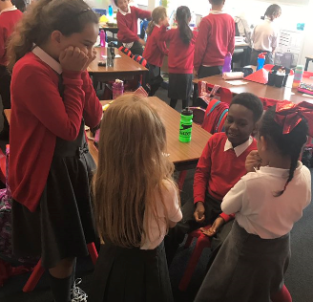
Customer & Business Services
Glasgow City Council
City Chambers
GLASGOW G2 1DU

Tel: 0141 287 0900
e-mail: customercare@glasgow.gov.uk

The above website also includes information on data protection and freedom of information.
Sharing Our Learning

CURRICULUM
Curriculum for Excellence 3-18
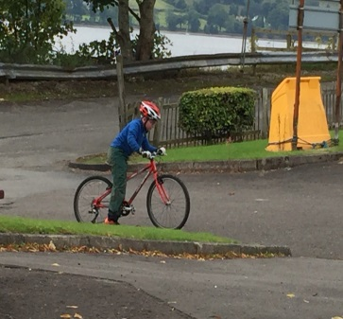
Curriculum for Excellence has been introduced to raise standards of learning and teaching for all 3 to 18 year olds. It aims to help prepare children and young people with the knowledge and skills they need in a fast changing world. As part of Curriculum for Excellence all children from pre-school to the end of S3 will receive a rounded education known as a Broad General Education (BGE). Curriculum for Excellence is all about bringing real life into the classroom and taking lessons beyond it.
Outdoor Learning

Through the experiences we provide at Corpus Christi Primary School we want our children to become Successful Learners, Confident Individuals, Responsible Citizens and Effective Contributors. We are committed to providing children with a broad general education and focus on eight curriculum areas.

EXPRESSIVE ARTS | HEALTH & WELLBEING | LANGUAGES | MATHEMATICS
RELIGIOUS & MORAL EDUCATION | SCIENCES | SOCIAL SCIENCES | TECHNOLOGIES

Progress in learning is indicated through curriculum levels as detailed below.

LEVEL | 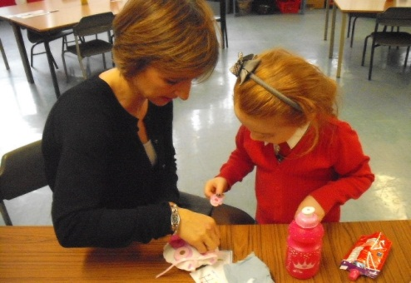  STAGE
Early | Pre-school years and P1 or earlier.
First | The end of P4 but earlier or later for some.
Second | The end of P7 but earlier or later for some.
Third / Fourth | S1 – S3 but earlier for some.  Learning Together

EXPRESSIVE  ARTS | The inspiration and power of the arts play a vital role in enabling our children and young people to enhance their creative talent and develop their artistic skills.

HEALTH & WELLBEING | Learning in Health & Wellbeing ensures that children and young people develop the knowledge, understanding and skills which they need now and in the future to help them with their physical, emotional, social and spiritual well-being.
SCIENCE | Science and its practical application in healthcare and industry are central to our economic future, for our health and well-being as individuals and as a society.
SOCIAL STUDIES | Through social studies, children and young people develop their understanding of the world by learning about other people and places both past and present, societies, their beliefs and values.
RELIGIOUS & MORAL EDUCATION | Religious and moral education includes learning about Christianity, Islam and other world religions and supports the development of beliefs and values.
LANGUAGES | Knowing other languages and understanding other cultures is a 21st century skills set for students as they prepare to live and work in a global society.
MATHEMATICS | Mathematics equips us with the skills we need to interpret and analyse information, simplify and solve problems, assess risk and make informed decisions.
TECHNOLOGIES | The range of subjects in technical education has changed significantly over the last two decades and now includes craft, design, engineering and graphics.

There will be opportunities throughout the year for parents and carers to learn more about aspects of the curriculum and to be consulted about significant changes if appropriate.

USEFUL WEBSITES

www.curriculumforexcelencescotland.gow.uk
www.educationscotland.gov.uk/parentszone/index.asp

RELIGIOUS OBSERVANCE
Our school is fortunate to have a close link with the local church. The priest assists with the Christianity element of Religious and Moral Education and provides opportunities for religious observance. Parents have the right to withdraw their child from religious observance and should inform the school in writing.

ASSESSMENT & REPORTING
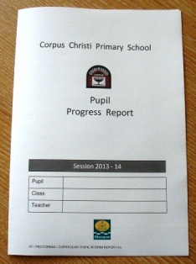
All children are assessed both formally and informally throughout the year. This allows children and their teachers to identify their strengths and areas for improvement. A variety of assessment methods are used to enable staff to pass on information to parents about the progress of their child. Assessment records are kept by the class teacher and form the basis of discussion at Parents’ Evening in November and April. An annual report is sent to parents towards the end of each school year.

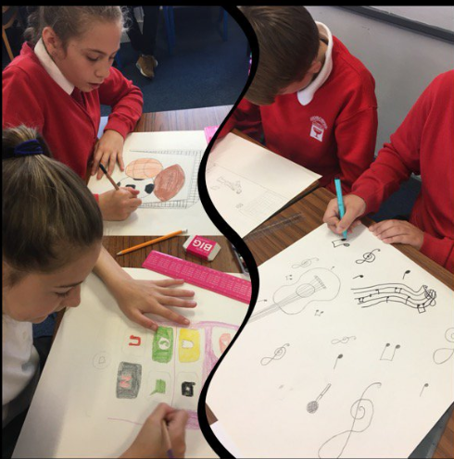
PUPIL PROFILES

Every child leaving primary school in Scotland has their key achievements in school, at home and in the community documented within a P7 profile. The content of the profile is decided by the young person. The profile is a positive record of their achievements with emphasis on their strengths. The profile provides a valuable way for learners to share valuable information about their achievements with their parents and teachers in secondary school.
GROUP WORK

SUPPORT FOR PUPILS
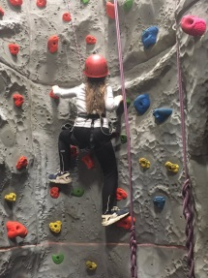
The school has a duty to ensure that all pupils have equal access to the curriculum, with appropriate support for their needs if required. This applies to the content of lessons, teaching strategies and minor adaptations to the school environment. There are a wide range of factors which may act as a barrier to learning. We are committed to working closely with parents and carers to ensure that they are fully involved in any decisions about support for their children’s needs.

Any parent or carer seeking further advice regarding this policy should contact the Head Teacher in the first instance.
Scaling Great Heights

Further information relating to additional support needs is available on the Glasgow City Council website: www.glasgow.gov.uk

Information on the Glasgow City Councils’ Parental Involvement Strategy can also be found at https://www.glasgow.gov.uk/index.aspx?-17870

THE NAMED PERSON

GIRFEC stands for ‘Getting It Right For Every Child’. This is the Scottish Government-led approach to making sure that all our children and young people – and their parents or carers – can get help and support when needed from birth through to age 18 (or beyond if still in school).

The vast majority of Scotland’s children and young people get the love and support they need from within their families and their wider, local communities. But even the most loving and caring families can sometimes need extra support. The GIRFEC approach aims to make it as easy as possible for any child or young person (and their parents) to get that help or support when they need it.

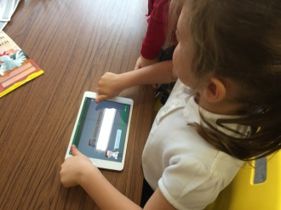
To access support when needed, Part 4 of the Children and Young Person Act (Scotland) 2014, states that every child in Scotland has a Named Person, as a single point of contact. This Named Person has a responsibility to provide help and support when asked and can draw together other services if needed, co-ordinating help for the child or parents.

The Named Person will be a promoted teacher within the school. The name of the individual Named Person for your child(ren) will be provided.

Please do not hesitate to contact the school if you want to speak with your child’s Named Person.

SCHOOL IMPROVEMENT

On an annual basis, you will receive a copy of our Standards and Quality report. Copies from previous years are available on the school website. The Standards and Quality report highlights progress in key curricular areas such as Literacy, Numeracy and Health & Well-being. Our priorities for improvement are detailed in our School Improvement Plan which is discussed with our Parent Council. Any parent or carer seeking a copy of the plan can contact the school office or check out our website.

PROMOTING POSITIVE BEHAVIOUR

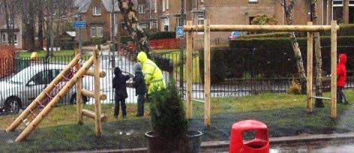
Children’s Rights as outlined in the UNCRC (United Nations Convention on the Rights of the Child) are fundamental to a good school ethos. Adults in our school will work with children to ensure they are aware of their rights and fully respect the rights of others. Therefore, the approach within Corpus Christi Primary is to build a positive ethos that demonstrates care and respect for all. Positive behaviour is recognised and celebrated. Our school operates a system of class charters to set out expected behaviour. This is celebrated through Gold Time treats, awards at assemblies and certificates sent home to parents etc. We also have a very effective ‘House System’ which impacts very positively on our school ethos. The highest standards of behaviour are expected of pupils at all times. Where this is not the case, a variety of sanctions are used. Parents are asked to co-operate with the school in encouraging a sense of responsibility and good behaviour in their children.

HOME LEARNING

Continuing to learn at home helps children to achieve more and is a vital part of our partnership with parents. Please check your child’s school bag for communication about home learning and specific tasks. We provide pupils with an excellent ‘homework’ diary which allows for communication with parents and for pupils to record their ‘Learning Logs’. This provides details of any achievements and identifies their next steps in learning.

PARENT COUNCIL
We have a very active Parent Council that represents the views of all parents. All parents are welcome to attend Parent Council meetings and can become members at the AGM in September. Parent Council minutes are available on the Parent Council page of the school website and on request from the school office. A list of current members is also available on the website.

PUPIL COUNCIL
Our Pupil Council is made up of 2 representatives from each year group. This is an important group which ensures that the views of pupils are heard.

EXTRA CURRICULAR ACTIVITIES
We have a wide range of activities that run between Monday-Friday to extend the learning experience. These currently include arts and crafts, dance, basketball and football. Please check your child’s school bag for information as places are popular and usually limited.

Good links with community organisation and our Active Schools Co-ordinator are vital for the success of these programmes.

USEFUL ADDRESS

Education Services
City Chambers East
40 John Street
GLASGOW G1 1JL

Tele: 0141 287 2700
www.glasgow.gov.uk

