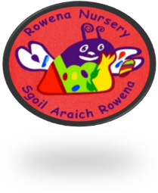

Rowena Nursery - December 2021 Newsletter

Dates for the Diary
Wednesday 15th December
Wear a Christmas jumper day if your child wishes to participate
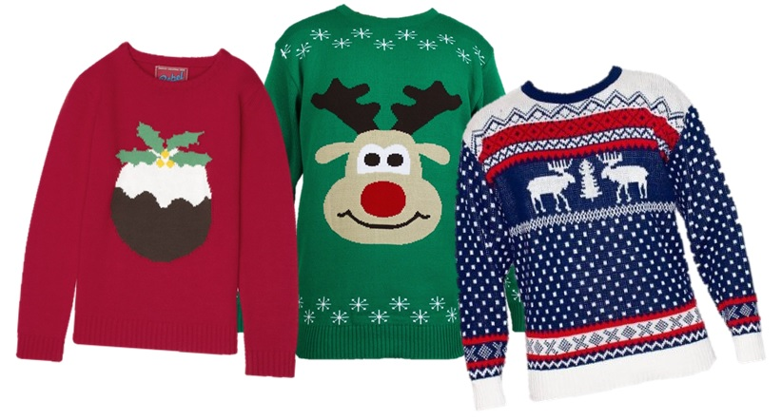
Friday 17th December
We have a story telling company
‘Thistle be Fun’ coming to entertain us with ‘GruffaHoHoHo’
10 – 10.45am
If this is not your child’s day they are welcome to join us for the show (45 minutes)
Tuesday 21st December
Party time 9.00am – 11.00am
All children are invited to join us. If this is not your Child’s day or session they are very welcome to come along from 9.00am– 11.00am There will be a ‘special visitor’ leaving presents for the children.

Any questions please ask a member of staff.

Spare Clothing
Can we remind all parents to bring and leave a change of clothes to nursery in case your child needs changed. Can we also ask that you clearly label clothing as children at times can have the same outfits/jackets as this will save the confusion.

Thank You.
Allergies
Gentle reminder to all parents/carers when dropping off their children to the nursery they should have no food with them. Within Rowena we have many food intolerances and allergies. We appreciate your help with this and supporting us to keep all the children and staff at Rowena safe. With the exemption of pre-arrangements already made with the management regarding children pack lunches.

Nursery Fund
We would like to say THANK YOU for your parental contributions to our nursery fund, we appreciate your continued support. Whilst this is a voluntary contribution of £2.00 per week, we rely heavily on these additional funds to supplement extra resources for the children so your support is very much appreciated. If you would prefer to pay monthly or termly, please have a word with Maureen or Annette in the office and this can be arranged. You can also pay direct into the Nursery bank account: -
Sort Code 80-07-15
Account Number 00754036
Please remember to put your child’s name as the payment reference so we can allocate it to the correct child

Car Parking
Can we politely remind all including extended family members who may be picking up, and dropping off, that the car park is for STAFF use only. This is to limit the movement of traffic in areas where our children are accessing. I believe there have been a few near misses in the past and has been used by parents out with the nursery too. This is something that cannot be tolerated. We really appreciate your support to ensure our children are kept safe and well.

Christmas Holidays
Term time chiildren will finish on Wednesday 22nd December
50 week children will finish on Friday 24th December
Rowena Nursery will open back up on 8am Wednesday 5th of January 2022

COVID-19 Update
At the moment our staff will continue to follow government guidelines and continue with the required 1-meter distance from other adults. All staff will wear a face covering when moving around the nursery.
Can we also remind parents that they MUST wear a face covering at pick up and drop off unless they are medically exempt and please keep a safe distance of 1-2 meters to keep yourself and others safe.
Within our playrooms the windows are still being left open for ventilation, if you can provide your child with a jumper, cardigan or fleece to help keep warm – please write your child’s name on them.
Thank you again for your continued support and understanding

Welcome
We would like to give a warm welcome to Linda who is our new Team Leader and Rachel (supply) Child development officer who has joined Rowena I’m sure they will be a great asset to the team.
Sadly, George our acting up Team leader and Angela Child development officer have both left us to embark on new adventures, we wish them all the best.

SWAY
All sways will be updated with all children learning before the christmas break.

Thanks, you to all parents/carers and families for supporting us with
- Halloween donations
- Morrison vouchers
- Sales of the Christmas scratch cards
We have redeemed our Morrisons vouchers and put an order in for garden tools and plants which are due to arrive in January 2022.
A huge thank you for all your generosity and donations towards the Christmas scratched cards sales. Final amount = £1300

We would like to wish all our families a very Merry Christmas and Happy New Year, from all the staff at Rowena Nursery.

