


NEWSLETTER

SEPTEMBER 2024



Nithsdale Road Nursery School,
264 Nithsdale Road,
Glasgow, G41 5LB
TEL: 0141 427 1896
www.nithsdaleroad-nursery.glasgow.sch.uk
Dear Parents 
Welcome back to all of our returning families and a warm welcome to all of our new children and families. The children have settled well this year and they are becoming more confident with the nursery layout and our routines.

Your opinion is very important to me and I believe that we cannot deliver the best service without your help. If there are any aspects of our service that you feel we could improve on or indeed there are aspects of our service that you particularly like, please let us know.

My email is Headteacher@nithsdaleroad-nursery.glasgow.sch.uk

I look forward to the next year working with you and getting to know you.


Child Protection

Whilst it is the responsibility of all for the welfare and safety of the children, as Head of Nursery, I am the named child protection coordinator and I am responsible for any child protection issues that may arise.

Staffing

Our focus for the beginning of term is all about getting to know each other, learning new routines and developing relationships. The children have now all been grouped and have a named key worker:

Head of Nursery
Annemarie Miller

Team Leaders
Mary Cumming
Tracey Docherty

Child Development Officers
Red – Amina Alam/Liz Trainer
Blue – Emma Hobbs/Noreen Ejaz
Green- Angela Keegan/Carly McMillan
Yellow- Julia Connolly/Ammara Afzal

Support For learning Workers
Siobhan Blair
Megan Ross
Nadia Khan

Clerical
Eileen McCafferty

Therese Moore is our English as an additional Language Teacher and she is here Wednesday and Thursday till end of November.


Change of Clothes

As we say goodbye to summer and the weather changes it is important that your child has a hooded waterproof jacket and wellies for outdoor play (the nursery has a good supply of outdoor clothing so don’t worry if you don’t have your own) You are welcome to leave a jacket here. It is also a good idea to put your child’s name on their belongings. Each child has a wee bag in the cloakroom where they can keep a change of clothes. If you need your bag replaced see Eileen.

Promoting Positive Behavior

All staff have high expectations on how children behave at nursery and this is supported by the use of Golden Rules.
You will receive a copy of our Golden Rules. Please talk to your child about the rules and how they apply both at home and in nursery:

- We are gentle.
- We are kind and helpful.
- We listen.
- We are honest.
- We work hard.
- We look after everything.

Our Golden Rules are displayed around the nursery.

We are being increasingly asked about toilet training advice.
Here are some tips which might help.


Preparing for toilet training:

You can start to get your child ready for toilet training so that it’s not such a surprise when the time comes:

- Say what you’re doing when you change their nappy, “you’ve done a wee, let’s put a clean, dry nappy on”
- Change nappies in the bathroom – this is where we do our toileting business
- Change them standing up
- Encourage them to flush away poo
- Get them to wash their hands after a nappy change
- Look at a book about potty training together, there are lots of books aimed at toddlers with lots of pictures
- Let them see what you do; children learn by copying and they need to see what is normal.

Once you feel they’re ready, buy some pants and go for it! If you’re able, it’s fun for your toddler to be involved and go with you to choose their first underpants.

Don’t confuse them by putting a nappy on when you’re out and about, just take a potty/travel potty with you. If you’re going out and about in the car it’s a good idea to put a towel down on their car seat to protect it.

Further advice can be found on NHS website - www.nhsggc.uk/kids

Parking

Please be a courteous driver and do not park on our double yellow lines. Thank you to those drivers who park with due consideration and co-operation.

Care Plans

Thank you for taking the time to complete care plans with your child’s key worker. It is helpful to have as much information about your child as possible. If you haven’t already completed a plan please see your child’s keyworker and they will arrange a time that suits you both.


Nurture Workshops

Glasgow City Council’s vision is to be a nurturing city and is committed to embedding the 6 Nurture Principles into practice across playrooms and classrooms throughout the city. Larissa Cunningham our link Education Phycologist is looking at the impact of nurture across the city but in particular looking at this from a multi- cultural perspective. We will be offering a series of 6 workshops over the next 6 months looking at the nurture principles. Tracey and Ammara will be hosting these workshops and we are keen for parents to be involved. The first workshop will be 30th October. Please speak to Tracey if you are interested

Starting School Workshop 

Posters regarding starting school in August will be displayed on the front door and also at the back gate. This is on 8th Oct at 10:15am. Please note that this is for ALL SCHOOLS and not just St Albert’s PS. Preparing your child for school and support in enrolment.

Lending Library


Our lending library will be up and running after the September weekend. The library is situated at the top of the stairs. Please take as many books as you like. There is a folder there where you can write in your child’s name, title of the book(s) and date. Please remember to return them. There are book bags which can be used to transport your books.

Garden Fencing

We are hoping to create a new space in the garden by putting up some fencing. If anyone who has connections to any fence builders we would appreciate any advice or help. Also looking for quotes. We may look to do some fund raising to help us achieve this.

Toy Fund 

Thank you for your continued contributions and support with toy fund. The toy fund pays for children’s parties, Christmas and birthday gifts and nursery resources.
Remember you can pay Eileen your toy fund (£3.00 per week) weekly, monthly or termly.


Front Gate

Could everyone please remember to close our front gate when they enter and leave the building. It is much appreciated.

African Adventure 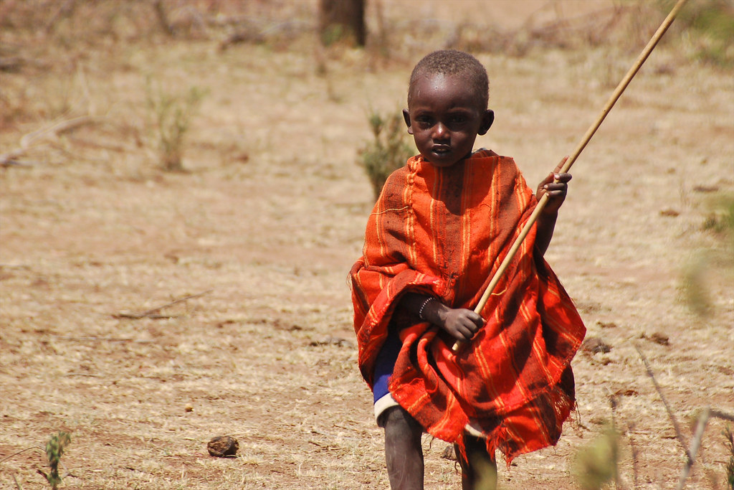

Megan our support for learning worker will be heading to Nakuru in Kenya this week (27th September to 11th October) Megan will be part of a team of charity workers who are involved in building a school in the area. They will be helping with the build as well as getting vital resources to the local area including local orphanages and maternity hospital. We are super proud of Megan and wish her safe travels. Good luck Megan!

Wedding News 

I am sure you will join with us and congratulating Julia on her recent marriage to Bernard (Bernie) on the 3rd September. They both had a lovely time and we wish them all the best for the future.

Holidays

The nursery will be closed
Friday 27th September and Monday 30th September.

October Holiday

The nursery will also be closed for in-service day
Friday 11th October and then from Monday 14th October to Friday 18th October

A full list of school holidays can be found on Glasgow City Council’s website.

Glasgow.gov.uk

