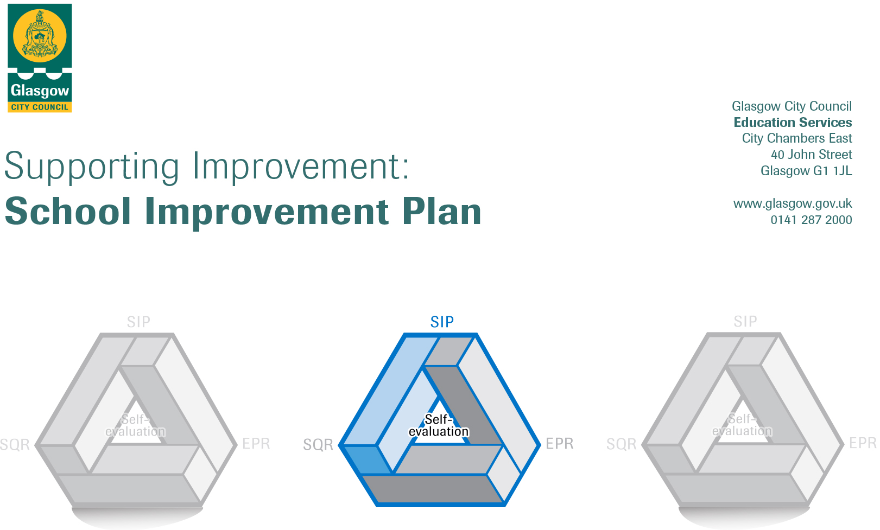

Session: 2018-19

Establishment |  | Nithsdale Road Nursery School
Head of Establishment |  | Annemarie Miller
Area/Local Improvement Group |  | South Lig 2
Head of Service |  | Donnie MacLeod
Area Education Officer/  Quality Improvement Officer |  | Louise Hamilton/Sharon Constable

CONTENTS
1. Vision, Values and Aims
2. Summary of Self-Evaluation Process / Priorities for Improvement in the current session
3. Action Planning

Action Plan Summary for Stakeholders

1. Our Vision, Values and Aims
Our Vision at Nithsdale Road Nursery School is to work in partnership with parents, cares and the community to offer a safe, secure, caring, healthy, respectful, inclusive, stimulating learning environment where each child achieves their full potential.

Our Values at Nithsdale Road Nursery School are the characteristics that we believe are essential for lifelong learning:
Children need to be able to adapt to different experiences and achieve emotional wellbeing. They need to take responsibility, recognise and manage their own feelings and understand the feelings of others, have a sense of independence and self-worth, form and maintain positive, mutually respectful relationships with others, be able to solve problems and make informed decisions and have a sense of purpose and goals for the future.

2. Summary of our self-evaluation process.
Our self- evaluation focuses on key aspects of our children’s successes, achievements and well-being. An effective system is in place to monitor the quality of the work of the nursery and to gather the views of the staff, parents, children and other stakeholders. Staff work together to evaluate provision and together we make improvements and changes were needed. There is focus on continuing improvements to learning and teaching as well as improvements in achievements of all children. Strengths and areas for improvement are clearly identified. Our self- evaluation draws on a wide range of evidence. Staff are reflective practitioners and share good practice. Complete review undertaken using How Good is Our Early Learning and Child Care. This is reviewed yearly

Strengths identified:

Priorities for development:
1: Managing change and maintaining quality

2:Moderation

3:Environments

3. Action Planning

No. | Quality Indicator | Priority
1 | 1.3 Theme 3  1.4 Theme 2 | There is a clear cohesion between professional learning and professional development to ensure quality lies at the heart of what we do. SMT are highly visible and motivate others with changed being managed at a sustainable pace with regular opportunities available for professional dialogue and discussion resulting in positive outcomes for children.

 | Tasks to achieve priority | Timescale  and checkpoints | Evidence of Impact > (data, observation, views)
 | All staff to revisit Documentation ( Folder in place) | September 2019 | Remits, roles and responsibilities are clear to all staff.
 | PDP Calendar | September 2019 | Opportunity to personalise training and development needs
All staff to keep track of training and impact on CPD Manager |  | October 2019
Regular meetings to track progress |  | I per term | Opportunity for reflection
Staff Questionnaires |  |  | Support self- evaluation licked to change
Attendance at Mentally Healthy workplace Training for Managers |  | June 2019 | Development of good practice to prevent/ manage stress within the establishment as a result of impact of change Promotion of health and wellbeing for staff.

Staff leading on this priority – including partners | Resources and staff development
SMT  Tapestry Programme  Early Years Scotland  Glasgow City Council  Team Leader Cluster South LIG 2  Digital Leader of Learning | Calendar of Training in place.  PDP for all staff  Common Core of Skills, Knowledge & Understanding and Values for the “Children’s Workforce” in Scotland. Scottish Government Document  Building the Ambition  Early Learning and Childcare-National Induction Resource  Mentally Healthy Workplace Training Pack

No. | Quality Indicator | Priority
2 | 2.3 Theme 3 | Evidence of children’s progress is consistent and robust. Moderation is used to raise standards and expectations across the early level with practitioners taking a collegiate approach to reach agreements. Good use is made of assessment tools/frameworks to ensure our evidence is reliable and valid. Opportunities are in place to involve parents in this process

Tasks to achieve priority | Timescale  and checkpoints |  | Evidence of Impact > (data, observation, views)
Moderation Champions identified | June 2019 |  | Training program to be put in place
Moderation of Numeracy trackers (cluster) | May 2020 |  | Numeracy trackers used effectively to make judgements around children’s learning.
Team Leader to attend training sessions | August 2019 |  | South Lig 2 will take part in inter authority moderation.
Moderation cycle is revisited | September 2019 |  | Moderation is understood by all practitioners
All staff involved in Tapestry Programme | On-going throughout year | Opportunities for practitioner reflection, personal development and professional dialogue in order to enhance practice and maintain quality.
Regular staff meetings | On going | Opportunities for reflection.

Staff leading on this priority – including partners | Resources and staff development
SMT  Team Leaders  Parents  CDOs | Attendance at master class and tapestry programme.  Opportunities for Team Leaders to further enhance leadership skills.  Self- evaluation of service by parents (questionnaires)

No. | Quality Indicator | Priority
3 | 3.2 Theme 2  2.2 Theme 1 | Ensure our learning environment is enabling, rich, varied, nurturing and safe. Children are motivated and stimulated within our playrooms contributing to their learning and engagement. Careful consideration is given to resources, pace of day and sensitive interaction.

Tasks to achieve priority | Timescale  and checkpoints | Evidence of Impact > (data, observation, views)
Good practice visits | October 2019 | Share and implementation of good practice.
Research | On going | Materials made available for professional reading and reflection
Whole team approach | August 2019 | All staff responsible for playroom management and organisation.
Allocation of roles | September 2019 | In conjunction with SIP
Playroom organisation | Starting August 2019 |  | Playrooms are utilised effectively in order to best meet needs of all children with consideration given to pace of day and routines
Work in close consultation with parents | Throughout year |  | Opportunities for parents to be consulted and included in order that change is managed effectively.

Staff leading on this priority – including partners | Resources and staff development
Head of Establishment  Team Leaders  CDOs  Parents  Bilingual staff  Local establishments | Work in close conjunction with other establishments in LIG

