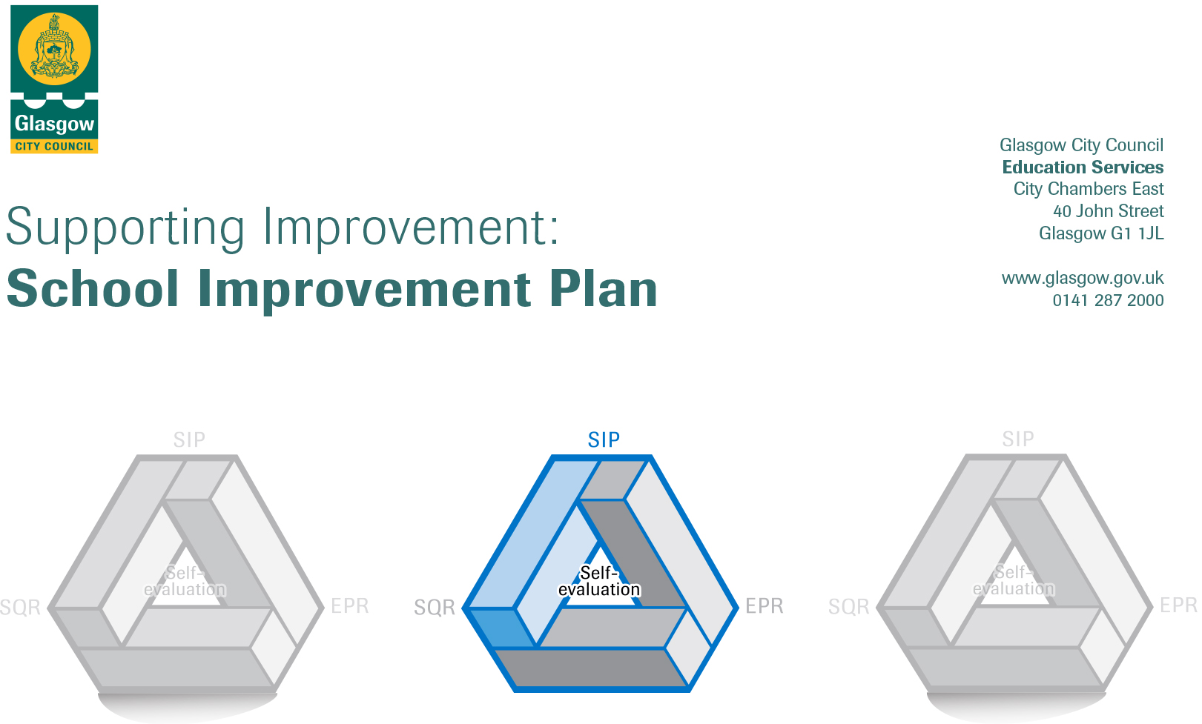

Establishment |  | Lime Tree Day Nursery
Head of Establishment |  | Eileen McGeoch
Local Improvement Group |  | South, Area 1
Head of Service |  | Maureen McKenna
Area Education Officer/  Quality Improvement Officer/Link Officer |  | Sharon Constable

CONTENTS
1. Vision, Values and Aims
2. Summary of Self-Evaluation Process / Priorities for Improvement in the current session
3. Additional Monies Spend Summary of Consultation Processes
4. Action Planning

Action Plan Summary for Stakeholders

1. Our Vision, Values and Aims
Our vision: Lime Tree Day Nursery where we learn and grow together.

Our values: Love, nurture, respect, inclusion, safe, excellence, fun

Aims:

Love. All adults offer children professional love which supports their emotional wellbeing. Adults know their children well offering high levels of nurture and support.

Inclusion. We recognise and support individual children’s personal learning needs while ensuring GIRFEC principles are embedded in practice. We work together with other agencies and professionals to support children’s holistic learning and development needs. We strive to become advocates for children where we protect, safeguard and celebrate children’s learning and successes. Children’s rights (UNCRC) underpin all our practices within our diverse and inclusive establishment.

Motivate. Adults are dedicated, enthusiastic, knowledgeable and motivating. Adults respond to the interests and needs of the children, the children will become Confident Individuals, Successful Learners, Effective Contributors and Responsible Citizens.

Education. Adults provide enriched learning opportunities both indoors and outdoors. Children have opportunities to learn, develop and be challenged in their learning, reaching their full potential.

Trust. Relationships, relationships, relationships! We recognise and advocate an ethos of positive relationships which are built upon mutual trust and respect. We have an open-door policy where everyone is welcome and included.

Respect. We respect and value others. We encourage stakeholders to share their diverse beliefs, values and opinions as we learn together about the people within our community.

Environment. Our environments are safe, warm, friendly, inclusive and nurturing where children feel safe. Our stimulating environments offer children support and challenge in their learning.

Engagement. We aspire to work in close partnership with our families. We recognise and celebrate our diverse community as we learn, develop and grow together. We involve our families with their children’s learning journey recognising the importance of their learning at home as the primary and most important learning environment.

2. Summary of our self-evaluation process.
Self – evaluation is based on Education Scotland document, ‘How Good is Our Early Learning and Childcare’, ‘Realising the Ambition’ and ‘Health and Social Care Standards’. We continued to develop our practices with a focus on the service recovery and re-connection following the onset of COVID-19 pandemic. This academic year has highlighted many challenges with restricted opportunities for face-to-face self-evaluation and improvement. As an establishment, we have worked together to use alternative and innovative ways to overcome such challenges. We initially started having Microsoft Teams staff meetings weekly during lockdown periods. Staff participated in a wide variety of online learning and training both individually and as a whole staff team approach. This in-turn has also developed staff IT skills and confidence. To continue to engage with our families, other agencies and professionals, we created a conference call system which allowed us to continue with our partnership approach ensuring children’s holistic needs and development were being met. This is a system which we will continue to use for the foreseeable future until restrictions are fully eased.

Staff work patterns and children’s patterns of attendance were adapted to fully follow and support Scottish Government guidelines. This continued to be reviewed and adapted as and when Scottish Government advice evolved. Children’s 1,140 hours placements were prioritised following Glasgow City Council’s guidance prioritising children with additional support needs, children whose parents were working and children of lone-parent families.

Clear policies and robust establishment risk assessments followed Scottish Government advice and guidance from Glasgow City Council’s health and safety team. Practitioners were consulted with and these were shared with practitioners and understood. In addition, all updated guidance, polices and risk assessments were shared with all parents/carers via email. Paper copies where available on request.

Each practitioner was given the opportunity for termly pastoral care meetings with the Head of Centre/Depute Head of Centre to support their emotional wellbeing. Our practitioners are encouraged to share their thoughts, feelings and opinions where they are listened to. Pastoral care meetings will continue into the next academic session.

Staff supported the children’s emotional wellbeing as they continued throughout this academic session working within small playroom bubbles. In-house PATHS training was delivered by our trained practitioner as a refresher for almost all staff. The programme began and continues to become embedded into practice. We will explore further training opportunities for staff. All staff completed a nurturing principles questionnaire and responses were analysed and discussed with our link Educational Psychologist. A series of training opportunities will be developed to ensure that nurture is applied as a full establishment approach. To date, our link Educational Psychologist has provided attachment and nurture training to almost all staff. This will continue into next session.

The culture and ethos within our setting is positive, nurturing and caring. All stakeholders were consulted with as we revised our vision, values and aims. Staff observed and consulted with the children to gather their views. Responses from parental consultations are as follows:
- 100% of responses said they were aware of our current vision, values and aims
- 22% of responses said they felt our current vision, values and aims weren’t too long
- All responses chose ‘safe’ as an important ‘buzz’ word
- Further suggested ‘buzz’ words include fun, respectful, friendship, safe, happy, outdoors

Children’s environments were adapted and developed following national Scottish Government advice. These continued to be as nurturing and as warm as possible while offering stimulating and challenging experiences for the children. Our practitioners were supported to develop their knowledge of early level numeracy progression which was led by the Leaders of Early Learning Team. Almost all staff members attended training sessions via Microsoft Teams. Further aims for staff was to increase their confidence using the numeracy framework to identify children’s learning and next steps. In addition, we aimed that almost all children would have increased opportunities for numeracy learning experiences both indoors and out. The data from the intervention is as follows:
- At the beginning of the intervention, only 45% of practitioners felt confident in their knowledge and understanding of Early Level number progression. All practitioners (100%) were confident at the end of the PDSA.
- At the beginning of the intervention, 36% of practitioners were confident in using the framework to identify children’s learning and next steps. At the end of the PDSA all practitioners (100%) felt confident.
- At the beginning of the PDSA only a few practitioners had a clear understanding and knowledge of preschool children’s numeracy learning within their group. At the end, the majority of staff had a clear understanding of all children’s numeracy learning within their group.
- All practitioners are confident in spotting opportunities to support and develop numeracy learning.
- All practitioners are confident in modelling numeracy and counting language.
- The majority of staff (73%) agree that the environment are resources indoors support rich literacy learning.
- The majority of staff (64%) agree that the environment outdoors supports rich numeracy learning.
- All practitioners agree that they provide regular opportunities for counting through relevant real-life experiences.

Through further group discussions and observations of our current planning cycle and recording of children’s learning, we collectively identified the need to develop the children’s learning environments, our planning cycle and how we record children’s learning. We will continue to develop this into next session.
Plans were in place to begin researching ways to record children’s individual learning in 2020/2021. Unfortunately, due to restrictions and vast changes within ELC and our setting which were out with our control, we were unable to consult effectively with stakeholders. We plan to consult with stakeholders and explore the possibility of using online learning journals for session 2021/2022. This will include a series of training for staff. We will begin our moderation journey in-house and in partnership with two other GCC establishments.
As part of our language and communication friendly programme (LCFE) which was being led by our link Speech and Language Therapist, almost all staff attended virtual training. Almost all staff have now completed video enhanced reflective practice (VERP). We will continue to audit and improve our environments and work towards validation and accreditation. Monthly strategies are shared with parents/carers via our Microsoft SWAY newsletter.
Following consultation with parents/carers, we have introduced a nursery Facebook page. This communication platform has complemented our existing Twitter page. Facebook has proved more popular with our families where they have openly shared children’s learning and development from home. This was extremely beneficial during both lockdown periods. Parents/carers will have the opportunity to complete a Microsoft Form to gather their views on using Seesaw to record children’s learning and use as a platform for two-way communication and family learning.

We had a member of the EAL team with us this last session. Almost all staff across the nursery participated in either face-to-face or virtual training with our EAL leaders of early learning teacher. We prioritised staff knowledge of EAL learners and developed an ‘all about my languages’ pro forma which will now be included in all welcome and enrolment packs for our families. We started to audit our resources looking at suitability and whether these truly reflected cultures and beliefs within our community. This will continue into next session where we will focus on looking at our environments and resources to support cultural and religious diversities and to support EAL learners within our establishment.
Strengths identified:
- Adult/child interactions are developing (continuation of language and communication friendly programme and validation)
- Stronger family engagement and family learning including home links during lockdown periods
- Implementation of nurturing principles as a full establishment approach striving to become part of Glasgow’s nurturing city (this will continue until embedded into practice)
- Increased knowledge of early level number progression. Evidence gathered in children’s individual numeracy frameworks.
- Establishing a revised shared nursery vision, values and aims which reflects stakeholder’s views and opinions.
- Responsive, innovative team who recognise the need for change and progression of service
- All practitioners had ample opportunity to undertake additional CPD during lockdown periods while working from home. This increased underpinning knowledge and increased motivation.

Priorities for development:
1: Planning, tracking and moderation (child-centre pedagogy in practice)

2: Applying nurture as a full school approach

3: Language and communication friendly establishment

3. Additional Monies Spend Summary of Consultation Processes
We successfully secured additional funding from Glasgow City Council to a total of £2000. This award was to enhance and replenish our existing outdoor learning clothing resources for all children and staff alike. This in turn increased our optimal daily opportunities for all children to access free-flow quality outdoor learning. The new resources allowed all children to be suitably clothed for all weathers. The additional resources allowed each child to have their own weatherproof clothes following the Scottish Government’s ELC COVID-19 guidance where no children should share clothing or footwear.

All of our pre-school children benefitted from their families in partnership packs where Glasgow City Council secured funding for all ELC settings. We developed a short video for our families explaining the programme. Staff took leaderships roles in planning, organising and distributing these packs to all of our pre-school children. Staff supported the children in nursery to use these resources before giving them home. Parents/carers were supported and encouraged to use these resources at home with their children. Our families sent photographs and evidence of their home learning and these were included in discussions with children, wall displays and individual children’s learning journals. Parents/carers were encouraged to complete the post intervention questionnaire to gather views.

Rationale for Spend:
- Increase daily outdoor learning opportunities for all children
- To support staff and children’s wellbeing
- Increase ventilation and safety for all children during COVID-19 pandemic
- To support all pre-school children’s school transition
- To support literacy, numeracy, health and wellbeing development of all pre-school children

Measures/Evidence for Impact (data, observation, views):
1: Children’s learning journals

2: Wall displays, literacy and numeracy tracking for children

3: Parental responses and evaluation of family in partnership packs

4: Increased daily opportunities for outdoor learning regardless of the weather conditions. Supports children and staff health and wellbeing in particular.

4. Action Planning

No. | Quality Indicator | Priority
1 | 2.3 Learning, Teaching and assessment | Planning, tracking and moderation (child-centre pedagogy in practice, RTA)

Tasks to achieve priority | Timescale  and checkpoints | Evidence of Impact > (data, observation, views)
Develop a unique curriculum rationale for Lime Tree in consultation with all stakeholders | Ongoing | Consult with staff, children and parents/carers. Evidence in Microsoft Forms questionnaire. New curriculum rationale will be included in our handbook and shared with our families during their enrolment.
Develop planning recording pro-formas for all playrooms 0-5 | December 2021 | Consult with staff. Audit our current planning and explore other recording methods using examples from GCC and the west partnership
Under 3’s planning opportunities for all under 3’s staff | October 2021 | All staff will have a better understanding of 0-3 developmental milestones and how to support and develop children’s learning. Evidence in children’s learning journals, planning and observations. Evidence is floor books and wall displays.
All children under 3 will have a literacy framework to support their learning and development | Ongoing | Microsoft Teams feedback from parents/carers using virtual learning journals  Children’s observations, next steps, learning journals
Embed Ferre Laevers observations into practice (learning and engagement) | Ongoing  (Training refresher August in-service days) | Evidence in observations and next steps for children’s learning.  Evidence in playroom self-evaluation and monitoring. Share powerpoint presentation with parents/carers and staff and include information in SWAY newsletter
All 3-5 children will have a GCC literacy and numeracy framework tracker (learning and engagement) | Ongoing | Microsoft Teams feedback from parents/carers using virtual learning journals  Children’s observations, next steps, learning journals
Staff training to use SeeSaw to track and plan for children’s learning (all children) | Ongoing | Parent/carer and staff consultation questionnaire using Microsoft Forms
Local moderation cluster group to develop knowledge, understanding and share good practice (Lime Tree, Laurieston and Carmichael Nursery) | Ongoing | Staff knowledge and understanding of the moderation cycle (child-centred pedagogy in practice) will increase. All staff will have moderation training opportunities. We will share good practice at a cluster level with Carmichael and Laurieston Nursery. All staff will begin to use national moderation paperwork.

Staff leading on this priority – including partners | Resources and staff development
- Senior Leadership Team (Lime Tree)  - Margaret Harper-Abdullah (Laurieston)  - Julie Shields (Carmichael)  - Sharon McGeever (GCC, moderation)  - Support from GCC colleagues already using SeeSaw (Eastwood and Castlemilk) | - Staff training refresher when using for Ferre Laevers observations  - Staff moderation training to increase knowledge and understanding of child-led pedagogy in practice  - Training and support from GCC moderation team  - Staff training to use digital learning platforms such as SeeSaw

No. | Quality Indicator | Priority
2 | 2.4 Personalised support | Applying nurture as a full school approach

Tasks to achieve priority | Timescale  and checkpoints | Evidence of Impact > (data, observation, views)
Staff questionnaires to enable a training calendar to be further developed | September 2021 | Staff and parent/carer self-evaluation questionnaires.
Attachment training for staff who did not attend previous session with link Educational Psychologist | September 2021 | Pre and post training questionnaires.
All behaviour is communication training for all staff | Ongoing | Pre and post training questionnaires. Playroom mentoring and  Observations. Evident in children’s WAP and individual plans, learning journals and trackers.
Children’s learning is understood developmentally training for all staff | Ongoing | Pre and post training questionnaires. Playroom mentoring and  Observations. Evident is children’s WAP and individual plans, learning journals and trackers.
Annual Child protection and safeguarding training for all staff | August 2021 in-service days | Mind-map with staff to gather areas for further training and development
PATHS training for staff supported by GCC Care Experienced Team | Ongoing | More staff training to lead PATHS sessions to support emotional wellbeing of pre-school children.
Staff ‘Be mindful’ training to support staff and children’s mental health and mindfulness | Ongoing | Staff knowledge and completion of course work. Evidence in children’s behaviours and coping strategies. Playroom monitoring and observations of children.

Staff leading on this priority – including partners | Resources and staff development
- Senior leadership team  - Link Educational Psychologist  - GCC Care Experienced Team  - Eileen – explore and secure funding for ‘Do be mindful’ training for a minimum of 6 staff members | - Continuous staff training and development around the 6 nurturing principles  - Do be mindful training for a minimum of 6 staff  - Further PATHS training for staff  - Observations of children including Ferre Laevers observations

No. | Quality Indicator | Priority
3 | 3.2 Securing children’s progress | Language and Communication Friendly Establishment validation and accreditation (LCFE)

Tasks to achieve priority | Timescale  and checkpoints | Evidence of Impact > (data, observation, views)
Validation assessment from LCFE validation team.  Audit of playrooms | December 2021 | Audits of playrooms before and after.  Accreditation of being a LCFE
Training for all staff from our link Speech and Language Therapist on literacy and communication development for children aged 0-5 | December 2021 | Staff pre and post questionnaires (Microsoft Forms)
All staff to complete VERP videos | September 2021 | Video evidence and assessment sheets. Mentoring and protecting time to analyse VERP videos.

Staff leading on this priority – including partners | Resources and staff development
- All staff  - Bron Edwards (link Speech and Language Therapist) | - Staff training for all staff (led by Bron Edwards)  - Audits of environments  - Developing language and communication rich environments indoors and out throughout all playrooms  - VERP video and mentoring time

