Hilltop Nursery School

Newsletter October/November 2021

Dear Parents/Carers
Welcome back to the new session in term 2 of the school year. Hilltop would like to offer a warm welcome all our new families. We are delighted how the children have settled. We look forward to working in partnership together. Our returning children have also settled back into nursery very well.

School Enrolment
Can any parent whose child is due to go to School in August 2022 be advised that registration will commence on Monday 1st November until Friday 5th of November 2021. If you need any help please don’t hesitate to ask. Our lovely Jennifer will advise and support you with this process.
Staffing
We are currently running the service with a full complimentary of staff. We hope this can continue in these unpredictable times with covid. We would like to welcome all our students who will be studying towards their HND, HNC, NC and Foundation Apprenticeships in Childcare. We look forward to supporting them through their journey in childcare.
Appropriate Clothing
Please be mindful that during messy experiences such as painting, gloop, playdough and water, we will try and encourage children wear aprons, however accidents do occur. Therefore, can I please ask you to dress your child in suitable clothes for these types of experiences. This will allow your child to access this curricular learning freely without causing them worry about spoiling their clothes. The nursery is also aware that it is costly to replace clothes stained with paint, therefore we would kindly ask that your child attends nursery in appropriate clothing.
Thank you for your continued co-operation on this matter.

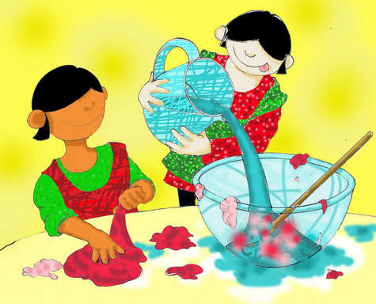
Our planning focus for the month
Books of the month - Book Winston Churchill & Dear Earth
The children will be learning all about COP26 with the focus on learning for sustainability in our environment.

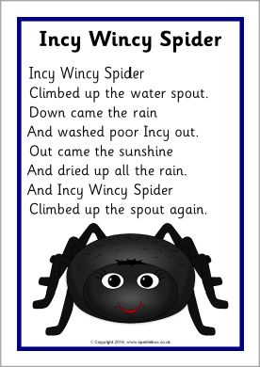
Our rhyme of the month – Incy Wincy Spider

Our Language and Communication Friendly Strategy for the month is:

‘COMMENT’
Try not to ask too many questions. Try to make short comments about what is happening right in front of you.
Planning
Through our monthly plans staff respond to children’s interests as well as seasonal and current topics. We encourage children to learn through play. Staff ensure the ‘learning environment’ is stimulating and captures your child’s interest to engage in learning. Your child will have many opportunities to develop their ‘Creativity and Curiosity’. This is an innate part of being human. It is the urge to learn and develop, to see what is around the corner, in the box or what happens next. We would also like you to note that, ‘the learning environment’ does not just refer to the physical environment of the nursery. It relates to the totality of the interactions, experiences and spaces we provide for your child. We can tell you a little more about our planning during performance of learning week.

Celebrations During this month is
Halloween will be celebrated throughout the week of 25th to the 29th of October. Children are welcome to dress up throughout this week but please can all loose props be left at home. Also please be mindful that children should be able to access the toilet independently.

Diwali festival of light -November
St Andrew’s Day – 30th November

Guy Fawkes Night – 5th November
Please be mindful of the dangers that comes with Guy Fawkes. Fireworks are beautiful but they can cause serious injury if not handled correctly.
Please follow Scottish Fire and Rescue Service Safety Advice.
Dates for the Diary
Bookbug week 8 – 12th November Throughout these dates there will be
different experiences for our children and their families.

Performance for Learning – Parents will be invited into the nursery to engage with their child’s keyworker about their child’s progress. This will be an opportunity to spend some time in your child’s learning environment and share their progress with them. You will be invited to look through your child’s learning stories to date. There will be a letter given out with exact dates and times for your child’s group. Please see the dates below:
Red room TERM TIME - This will be held on the week beginning Monday the 8th of November -Friday 12th November.
Green room 52 WEEKS - This will be held on the week beginning the 15th November-Friday 19th November.
Christmas is fast approaching the nursery have lots of potential events that we will be hosting we are just finalising some details and we will give you a timetable of our events so you can plan accordingly. Watch this space!!!!!

Photographer
Friday the 3rd of December Instant images will be visiting the nursery between 9.00 am – 3-00pm.
If you do not wish your child to have their photograph taken, place let a member of the management team know or your child’s key worker. There is no obligation to purchase these photographs.

