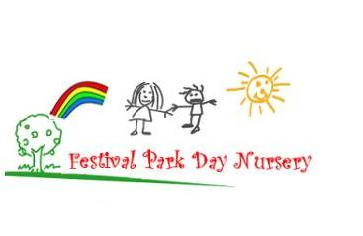**Festival Park Day Nursery December 2021/January 2022 Newsletter**

A big thank you to everyone who took part in Family Learning Week. It was great to see so many of the children’s videos on our Facebook page.

Thank you for taking part in our sponsored “Boogie a Thon” all funds raised will help provide valuable resources for your children and support us to continue to offer your children activities and experiences relating to the Curriculum. To date we have received £45. If you would still like to hand in sponsor money please hand it in at the main office or to your child’s keyworker.

Dates for your Diary: Tuesday 14th December - Christmas Party for all playrooms

Thursday 16th December - Christmas Jumper Day all children

Monday 20th December - Christmas Stall (you should already have received a letter with raffle tickets and a list of prizes are displayed at the main entrance).

Tuesday 25th January – Robert Burns Day

Unfortunately, due to Covid 19 restrictions this year we will be unable to invite parents into the building; Santa will still leave a gift but he won’t be handing gifts out to the children; also due to the current situation we shall not be able to hold our traditional Nativity Play. We shall however continue to have lots of fun Christmas activities during the next couple of weeks.

We will upload photographs of the children (where permitted) to Facebook and Twitter please feel free to comment on our activities and upload your own family celebrations from any festival you celebrate.

Your child’s keyworker will prepare a report on your child’s progress in order to keep you updated on all the things that they have been learning at nursery. This report will be communicated to you in January time.

**Nursery Holiday**

**Term Time Children: Last day in nursery is Wednesday 22nd Dec 2021**

**Children return Wednesday 5th January 2022**

**52 Week Children: Last day in nursery is Friday 24th Dec 2021**

**Children return Wednesday 5th January 2022**

Could we ask that all parents/carers ensure their child arrives at nursery wearing appropriate clothing for the elements of that day. Please ensure all children have a jacket on. Could you provide a change of clothing for your child and also ensure that they have a jumper/cardigan during the winter months.

Can we remind all parentsthat when you are bringing and collecting your child that you continue to maintain the 2 metres social distancing and use markings provided. Can all parents ensure that they wear a face covering unless exempt. If you are exempt could you wear your exemption lanyard.

We would ask all parents to be extra vigilant if their child has eaten nuts or sesame oil/seeds that their hands / mouth have been washed before coming into nursery. We would ask that you refrain from bringing any of the above to nursery. This is due to some of our children having severe allergies. Thank you for your co-operation.

We would like to take this opportunity to wish you all a Merry Christmas and a Happy, Healthy and Peaceful New Year

Email [headteacher@festivalpark-nursery.glasgow.sch.uk](mailto:headteacher@festivalpark-nursery.glasgow.sch.uk) Facebook page: Festivalparkdaynursery