**Festival Park Day Nursery**

**Handbook**

**62 Lorne Street**

**Glasgow**

**G51 1DP**

**Tel No: 0141 427-2301**

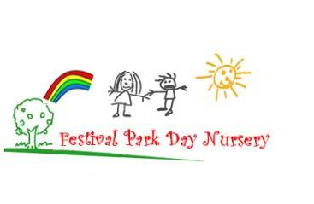



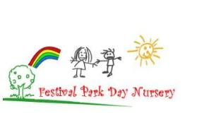

Festival Park Day Nursery

62 Lorne Street

Glasgow, G51 1DP

**T:** 0141 427 2301

**Email:** [Headteacher@festivalpark-nursery.glasgow.sch.uk](mailto:Headteacher@festivalpark-nursery.glasgow.sch.uk)

**Nursery Website:** [www.festivalpark-nursery.glasgow.sch.uk](http://www.festivalpark-nursery.glasgow.sch.uk)

**Glasgow City Council:** www.glasgow.gov.uk

**Facebook:** Festival Park Day Nursery

**Twitter:** @festivalnursery

Dear Parent/Carer,

The staff at Festival Park Day Nursery offers a welcoming, nurturing and positive ethos.

The nursery is a Glasgow City Council early years establishment which is non-denominational.

We strive to work in partnership to ensure the best learning opportunities for your child are on offer.

The aim of the handbook is to give parents/carers information, which we hope you will find both useful and informative.

If you have any suggestions or require any additional information which you feel would benefit the service, I would be happy to hear from you.

Yours Sincerely

Amanda Kelly

Head of Centre

**Establishment Staff**

Management Team

* Amanda Kelly (Head of Centre)
* Anne Marie Vernel (Depute)
* Leanne Pollard (Team Leader)

Clerical Support

* Pamela McLean

Taransay Playroom (3-5 years) - Child Development Officers:

* Leanne MacKinnon
* Lizanne Cherry
* Fiona McLean / Liz Brunjes
* Ellen Donald
* Joyce Evans
* Clare Quinn / Alana Brown
* Sofia Bertolaccini
* Caitlin Flannigan
* Cheree Rodgers

Harris Playroom (2-3years) - Child Development Officers:

* Karen Thomson
* Melissa Seils
* Hannah Docherty
* Laura Bryson / Wendy Kinnaird

Lewis Playroom (0-2yrs) - Child Development Officers:

* Caroline Ring
* Linda Bell
* Kyla McDowall / Heather Devine

E.A.L Teacher:Laura Lui

Modern Apprentice: Amy Irvine

Pupil Support Assistant**:** Razia Ali, Sadia Ali, Julie Cabrey & Nafisa Hassen

**Cordia Support:**

Cook: Patricia Hewitt

Catering Assistant: Mary Richardson / Janet McSorley

Janitor/Cleaning Supervisor: Elizabeth Stoney

Domestics: Linda McGilp / Karen McCartney

**Mission Statement**

**Our Vision, Values and Aims**

We offer a welcoming, fun, healthy, safe and nurturing environment where each child is supported to reach their full potential and learn the importance of respecting others. We work in partnership with parents and the wider community to encourage fairness, equality and social inclusion.

**Aims:**

* To create and maintain a positive and nurturing ethos.
* To value and respect the contribution of children, parents/carers and the wider community.
* To promote active learning and celebrate achievements throughout their educational journey.
* To encourage positive attitudes and self-esteem.
* To provide learning rich and positive experiences which enable the children to become successful and confident individuals.
* To promote each individual needs and to adapt the environment to enhance and encourage learning.

We encourage parents, children, staff, and the wider community to contribute their view and opinions; this helps to monitor our performance.

**Children’s Rights**

Our ambition is for all children and young people in Glasgow to know their rights and have these rights protected. To achieve this we need all adults to support children and young people in knowing their rights and working together to ensure these rights are protected. Article 12 of the UNCRC gives children and young people the right to be consulted in matters affecting them and to have their views listened to and considered. In Glasgow we are committed to listening to children and young people.

Glasgow City Council’s Listening to Children and Young People framework promotes children’s rights. The Glasgow Child and Family Plan states the vision for Glasgow’s children and young people as: “We want every child to be supported to achieve their full potential and contribute positively to their communities, throughout their lives”. For more information, please visit glasgow.gov.uk/index.aspx?articleid=17854

**Getting It Right For Every Child (GIRFEC)**

The *Getting it right for every child* approach is about how practitioners across all services for children and adults meet the needs of children and young people, working together where necessary to ensure they reach their full potential. It promotes a shared approach and accountability that:

* Builds solutions with and around children, young people and families
* Enables children and young people to get the help they need when they need it
* Supports a positive shift in culture, systems and practice
* Involves working better together to improve life chances for children, young people and families

For more information, please visit glasgow.gov.uk/index.aspx?articleid=19744

**Capacity**

0-2 years – 9

2-3 years – 20

3-5 years – 50 (full time equivalent)

We have 79 Full time equivalent places.

**Non-Denominational Policy of the Nursery**

The nursery is non-denominational, we respect and welcome children and parents of all religious faiths and beliefs.

**Age Range of Children in the Establishment**

We accept children from 6 weeks of age to school age.

**New Learning Community**

We are part of Govan/Bellahouston New Learning Community. We work in partnership with the local Primaries, Govan High School and Bellahouston Academy. There is an improvement plan in place for future developments.

**Hours of Opening**

The nursery is opened between the hours of 8.00am- 6.00pm.

**Nursery Sessions**

In August 2021, The Scottish Government will offer children aged between 3 and 5 and eligible 2 year olds 1140 hours free early learning and childcare. This also includes free school meals / snacks. The nursery will discuss daily sessions and hours at the time of enrolment. Due to restrictions in place in relation to Covid-19 there are smaller bubbles of children with a maximum of 33 families within each bubble. This is in line with current Scottish government guidelines.

**Establishment Year**

The nursery is open 52 weeks of the year with the exception of In-service days, public holidays, and between Christmas and New Year. For details of school term dates for children attending for 39 weeks, please visit [glasgow.gov.uk/article/17024/School-Term-Dates](https://www.glasgow.gov.uk/article/17024/School-Term-Dates)

**Information in Emergencies**

We make every effort to maintain a full educational service, but on some occasions circumstances arise which lead to disruption. Establishments may be affected by, for example, severe weather, temporary interruption of transport, power failures, or difficulties of fuel supply. In such cases we shall do all we can to let you know about the details of closures and re-opening. We shall keep you informed by using letters, notices in local shops and community centres, announcements in local places of worship and announcements in the press and on local radio.

**Home and Establishment Links**

**Parental Partnership**

**Our Aims**

* To recognise parents as the main contributor to their child’s education and development.
* To recognise the influence of parental love and care on all aspects of development.
* We welcome parent/carer contributions in the monitoring of the centre.

**Working with you**

Parents and staff work in partnership to settle a child into the nursery environment. The nursery staff aim to develop a close relationship with each parent in order that their child receives the very best of care and education within the guidelines of the Pre-5 services.

**Enrolment Procedures**

Once your child has been allocated a place you will be introduced to your child’s keyworker. Due to the restrictions in place in relation to Covid-19 this may take place outdoors.

During the visit one of the management team will update your information and complete the relevant documentation, including a Condition of Placement form and Enrolment Form.

Time will be set aside for you to share information about your child’s interests and development.

Your child’s hours will be built up over a period of time until we feel your child is secure in their new environment.

**Working together to Promote Positive Behaviour**

If we are experiencing difficulty with your child’s behaviour we will discuss this with you so that we can work together with an agreed plan to encourage positive behaviour in your child. Certain types of behaviour in young children can be disruptive and distressing to others e.g. biting, bullying, our main concern as a nursery staff is for the wellbeing and safety of the children in our care. Staff will be respectful, firm and consistent as they guide your child towards acceptable behaviour.

A policy on Promoting Positive Behaviour is available to read at the nursery.

**Triple P**

This provides positive parenting strategies which address a number of issues e.g. hitting, sleeping, toileting etc. If you require any support either individually or as part of a group we have staff available within the nursery to support you through this within the nursery setting/local area.

**Fundraising**

Parents, children and staff are involved in fundraising events to generate funds for the nursery. Local organisations are approached to lend support to the nursery by donations.

Fundraising continues throughout the year and is co-ordinated jointly by the parents and staff. They fundraise to buy birthday presents, Christmas presents, and travel expenses for excursions, summer trips etc.

**Parents Workshop**

We offer a variety of workshops throughout the year and hope that they may be of interest to you e.g. First Aid and Story-telling. We will keep you informed through the website and newsletters. Due to restrictions in place in relation to Covid-19 we are unable to take part in parent workshops at the moment.

**Children’s Progress**

All parents / carers have access to their child’s Individual Profile where evaluations are completed at the end of each plan. Your child’s progress can be reviewed and opportunities are available to discuss this with your child’s keyworker.

**Fees and Financial Information**

**Nursery Charges**

The charges for nursery provision will vary according to family circumstances and some families will be exempt from charging or entitled to a reduced fee level. The Head of Establishment can provide more information on the criteria for exemption or reduction. Charges will be payable 4 weekly in advance. You will be expected to pay for any additional hours of childcare your child is allocated, whether or not they are used. ( for instance A family allocated 9am-5pm will be expected to pay for the full number of hours even if they choose to collect their child at 4pm) confirmation of the additional hours allocated will be given in a written contract at the start of the placement. The government funding supports the provision of free part time nursery places for children aged 4 years and some 3 year olds which starts from the term following their 3rd birthday.

**Charges as from 2021/2022**

Hourly Rate - £3.00 per hour for children 0-3 years

Low Income Rate - £1.00 per hour for children 0-3 years

Hourly Rate - £4.00 per hour for children 3-5 years

Low Income Rate - £1.00 per hour for children 3-5 years

Kinship Carer Rate – £1.00 per hour

College/university Rate - £4.00 per hour

Second Child Rate - £2.20 per hour

Third Child Rate - £1.70 per hour

Non Glasgow Resident Rate - £5.00 per hour

**Meals/Snacks**

We are very fortunate to have our own kitchen and meals and snacks are provided by Cordia Service.

Lunch - £1.52 per meal

All children and young people of parents/carers receiving Income Support, income based Job Seekers Allowance, Working Tax Credit (where income is less than £6,240) and Child Tax Credit only (where income is less than £16,010) are entitled to a free midday meal. Information and application forms for free entitlement meals may be obtained from establishments and from grants section at Education Services headquarters. The nursery is not responsible for the collection of fees. Invoices will be made to Early Years charging team at Glasgow City Council.

**Arrears of Charges**

Where a parent/carer is weeks in arrears, a review of hours allocated will take place. This will, unless in the most exceptional circumstances, result in hours being reduced to part time entitlement for eligible 3 and 4 year olds, or in the case of children under 3 years old the place may be withdrawn. If for any reason you are finding it difficult to pay an invoice, please speak to a member of the management team as soon as possible. Your situation will be treated in the strictest confidence, and we will do all we can to advise.

**Nursery Policies and General Information**

**Administration of Medicines**

If your child is in need of medication whilst at the nursery you should discuss this with the Head of Centre. Nursery staff can only administer prescribed medicine. A form will need to be filled in which authorises nursery staff to administer the medicine. Nursery staff are not medically qualified. Should your child have a medical condition requiring treatment and monitoring e.g. epilepsy, asthma please notify a member of the management team so we can discuss a joint care plan. It is vitally important that you keep us up to date with any relevant changes.

**Dental Health**

The nursery is Smile Too accredited and provides curriculum activities relating to dental health. We encourage all parents to register their child at a local dentist. All children are provided with their own toothbrush which allows them to brush their teeth after snack.

**Illness**

If your child is absent due to illness, we appreciate if you could contact us to let us know by telephoning the nursery. If your child becomes ill while at nursery we will ensure they are as comfortable as possible whilst every attempt is made to contact you. Should the illness seem to be of serious nature, your child will be taken to The Queen Elizabeth University Hospital and you will be advised to meet us there.

If your child has any symptoms of Covid-19 we ask that you keep them at home and seek advice from your GP. If your child is required to take a Covid-19 test we ask that you call the nursery to inform us and then again when you have received your result.

The main symptoms of coronavirus (Covid-19) are:

• a high temperature

• a new, continuous cough – this means coughing a lot for more than an hour, or 3 or more coughing episodes in 24 hours (if you usually have a cough, it may be worse than usual)

• a loss or change to your sense of smell or taste – this means you've noticed you cannot smell or taste anything, or things smell or taste different to normal

**Accidents**

The nursery has a qualified First Aider. All accidents that occur within the nursery will be recorded in the accident book and parents/carers are called and informed of accident. On arrival to collect their child you will be asked to sign accident form. If in the event of an accident, where your child requires medical attention we will endeavour to contact you, if this is unsuccessful we will make necessary arrangements to take your child to hospital (The Queen Elizabeth University Hospital).

**Suitable Clothing**

Children have the best fun when they are doing messy work. We will always try to make sure they wear aprons but accidents happen so please dress your child in suitable clothes. Remember lots of fun and learning takes place outdoors, so please ensure your child is dressed for the weather. If your child travels by car please make sure they have a suitable jacket for outside play. It helps if you put your child’s name on their clothing to prevent confusion should we have two items the same. We also ask that your child has soft shoes/slippers in nursery to change into.

There are forms of dress that are unacceptable, such as items of clothing which:

- Potentially encourage faction (such as football colours)

- Could cause offence (such as anti-religious symbolism or political slogans)

- Could cause health and safety difficulties, such as loose fitting clothing, dangling earrings

- Carry advertising, particularly for alcohol or tobacco

- Could be used to inflict damage on other children or be used by others to do so

Glasgow City Council is concerned at the level of claims being received regarding the loss of children’s and young people’s clothing and/or personal belongings. Parents/carers should note that the authority does not carry insurance to cover the loss of such items and any claims submitted are likely to be met only where the authority can be shown to have been negligent.

**Arrival & Collection of Children**

It is expected that a responsible adult will bring and collect your child from nursery. In the interest of your child’s safety you should make a point of telling the Head of Establishment or staff members if someone different will be collecting your child. This avoids difficult situations when a child cannot be allowed to leave with an adult who is a stranger to staff. Tell staff, either in person or by telephone, who will be collecting your child. Please keep as close to hours as possible, as answering the door is time consuming unless most parents arrive at the same time.

Due to restrictions in place in relation to Covid-19 parent / carers will not be able to enter the building unless authorised by a member of the Management Team. Face coverings are required to be worn by both staff and parents on drop off and pick up of their child.

* On arrival parents and children within the 3-5 playrooms will line up using social distancing lines marked A and B. The children’s times have been staggered in order to maintain social distancing at our entrances as this is a public pathway and this help reduce congestion.
* A member of staff / management will greet the child at the front door and invite child into nursery.
* Staff member will sign child in and wash their hands after taking child into playroom.
* In the under 3 playrooms a member of staff will greet parent at their child’s playroom door. Parents will line up using social distancing lines provided and invite child into nursery. Child will be supported by member of staff to wash their hands.(If the ground to the under 3’s entrance is icy due to weather conditions a member of management will contact parents to advise them to use front entrance).

These changes will be kept under review.

**Emergency Contacts**

Parents whose children are in nursery are asked where possible to provide the establishment with names, addresses and telephone numbers of 2 contact persons in case of emergency. You are also asked to keep the nursery up to date with any changes in this information.

**Transition from Nursery to Primary School**

Through the year we develop links with our neighbouring primary school, Lorne Street. Children transferring take part in a buddy scheme with older children already attending school. Other local primary schools also receive our children. For details on local primary schools, please visit www.glasgow.gov.uk. An enhanced transition will be arranged for children who require additional support when starting Primary 1.

**Supporting Children with Additional Support Needs**

Sometimes children need a little help to fully access all areas of the curriculum. Staff will support children through a range of strategies, should your child require further support a range of services can be offered.

If it becomes apparent through a concern from yourself or staff observations that your child requires additional support, we would discuss this with you. With your permission, we would refer your child to the appropriate agency for support and advice. You child may then have an Additional Support Plan (A.S.P) drawn up to meet their individual needs. This process would include input from agencies involved, and also you as parents/carers. You will be kept up to date with the plan regarding the progress being made at each step. Your child will be allocated a keyworker who will liaise with various agencies and record any observations relating to the targets made by other staff and Pupil Support.

For more information, please visit glasgow.gov.uk/index.aspx?articleid=18941

**Child Protection (Management Circular 57)**

All educational establishments and services must take positive steps to help children protect themselves by ensuring that programmes of health and safety are central to the curriculum and should have in place a curriculum that ensures that children have a clear understanding of the difference between appropriate and inappropriate behaviour on the part of another person, no matter who.

Schools, establishments and services must create and maintain a positive ethos and climate which actively promotes child welfare and a safe environment by:

* ensuring that children are respected and listened to
* ensuring that programmes of health and safety are central to the curriculum
* ensuring that staff are aware of child protection issues and procedures
* establishing and maintaining close working relationships and arrangements with all other agencies to make sure that professionals collaborate effectively in protecting children

Should any member of staff have concerns regarding the welfare or safety of any child they must report these concerns to the head of establishment. The head, or the person deputising for the head, after judging that there may be grounds for concern regarding the welfare or safety of any pupil must then immediately advise the duty senior social worker at the local social work services area office of the circumstances.

These are the only circumstances under which your child would be discussed with another agency without your prior consent.

Although parents are not permitted to enter the nursery at drop off or pick up time if there was a Child Protection issue that we need to discuss with you a member of management would ensure that you would be able to enter the nursery.

**Data Protection Act 1998**

Information on children and young people, parents and carers is stored on a computer system and may be used for teaching, registration, assessment and other administrative duties. The information is protected by the Data Protection Act 1998 and may only be disclosed in accordance with the Codes of Practice. For further information please contact the establishment.

**The Freedom of Information (Scotland) Act 2002**

The freedom of Information (Scotland) Act 2002 enables any person to obtain information from Scottish public authorities. The Act applies to all Scottish public authorities including: The Scottish Government and its agencies; Scottish Parliament; local authorities; NHS Scotland; Universities and further education colleges and the Police.

Public authorities have to allow access to the following information:

* The provision, cost and standard of its service;
* Factual information or decision making;
* The reasons for decisions made by it.

The legal right of access includes all types of “recorded” information of any data held by the Scottish public authorities. From 1st January 2005, any person who makes a request for information must be provided with it, subject to certain conditions.

Further information is provided on the Glasgow City Council website:

[glasgow.gov.uk/index.aspx?articleid=17479](https://www.glasgow.gov.uk/index.aspx?articleid=17479)

Internet facilities are provided at all Glasgow City Council Public Libraries and Real Learning Centres.

**Dealing with Racial Harassment**

The Race Relations Act of 1976 makes it unlawful to discriminate against someone because of his/her colour, race, and nationality ethnic or national background. The Act makes it the duty of Glasgow City Council to eliminate unlawful racial discrimination.

In 1999 the guidelines, “Dealing with Racial Harassment” were issued to assist all teaching staff in dealing with such incidents.

The adoption of an anti-racist approach should be seen as one part of the continuing attempt to improve the quality of education.

Glasgow City Council recognises that support from the home is essential if these aims are to be achieved. Every child in Glasgow has the right to be happy and secure at establishment.

**Equal Opportunities and Social Inclusion**

There are equal opportunities for all children and young people in the centre irrespective of sex, race, religion and ability to participate fully in all aspects of the centre’s activities.

We aim to:

* Promote respect for each other and recognise and value difference.
* Help our children understand and challenge discrimination.
* Ensure that our approach and materials used in nursery are appropriate and meet the needs of all children.

**Bullying**

Bullying behaviour will not be tolerated within Glasgow City Council’s educational establishments. All children in Glasgow’s educational establishments have an entitlement to “work (and play) in a learning environment in which they feel valued, respected and safe and are free from all forms of abuse bullying or discrimination” *(A Standard for Pastoral Care in Glasgow establishments)*.

In 2009 Glasgow City Council published its revised anti bullying policy, incorporating the requirement to record and report all discriminatory behaviours within educational establishments. All establishments are required to review their policy in light of this. Parents and carers have a significant role to play in helping to address this problem. For this reason any anti bullying strategy must stress the importance of partnership with the parents and carers of their children.

**Five to Thrive**

A number of our staff have been trained in the new Five to Thrive imitative which is based on research that proves that how a parent behaves around their baby in the first three years of life has a direct impact on how their babies brain develops.

Information leaflets and workshops are provided covering the building blocks to support this initiative

* Talk
* Play
* Relax
* Cuddle
* Respond

**Realising the Ambition - Being Me**

This document which is used as a learning tool within the establishment builds on the documents Pre-Birth to Three and Curriculum for Excellence. This provides practical guidance and good practice within all age groups of children and encourages discussion and reflective questioning relating to the practise provided within the setting.

**How Good is Our Early Learning and Childcare**

This new revised self-evaluation tool which was implemented in August 2016 in place of “Child at -the Centre” and illustrates what good practice looks like. The establishment will use this tool to look at the service provided for all stakeholders and how this can be enhanced.

**Our Curriculum**

**Our Aims**

We provide an enriched learning environment to meet the needs of each individual child through working with the pre-birth to three document and Curriculum for Excellence.

Staff will endeavour to:

**Birth to Three**

Show genuine interest in both children and their families

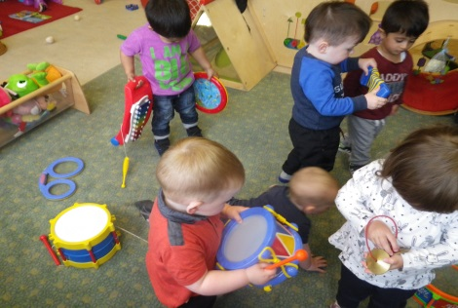Be responsible in ensuring and promoting positive relationships and the impact this has on children’s future outcomes and life chances

Ensuring an effective and high quality provision for young children and their families

Promote general wellbeing, health, nutrition and safety

**Curriculum for Excellence**

To develop self-esteem in every child

Promote attitudes, skills and understanding which will achieve effective learning skills

Develop social skills such as sharing, taking turns etc.

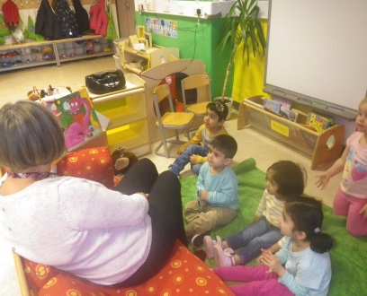Set acceptable standards of behaviour

**We aim for our children to become:**

Successful learners

Confident individuals

Responsible citizens

Effective contributors

**How we promote learning:**

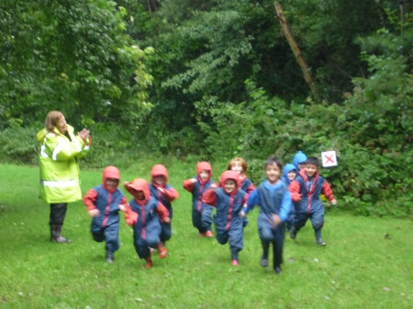

Encourage understanding of what has been learned

To share experiences with the child

To provide positive feedback and praise

To encourage children to share responsibility for the selection and maintenance of resources

**What we do:**

We allow time for children to explore, initiate and extend play

Create space in which children may play alone or with others

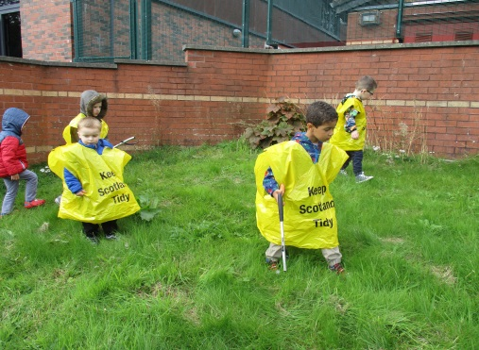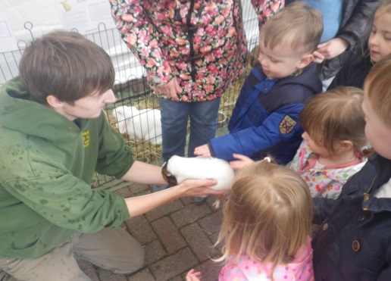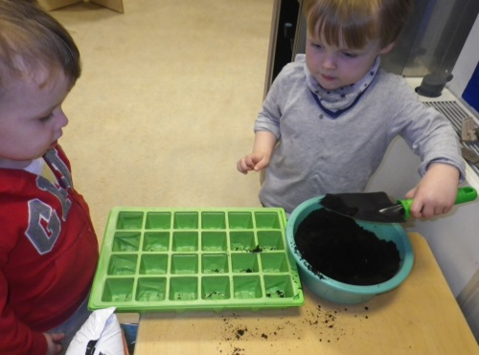Provide materials and equipment, which are varied and plentiful and appropriate to the children’s culture, experiences and interests

**A Curriculum for Excellence**

Curriculum for Excellence is a curriculum for children and young people age 3-18 years, it recognises that children learn through all experiences, in the family and community. The aspiration is that every young child should become Successful Learners, Confident Individuals, Responsible Citizens and Effective Contributors in life.

**Confident Individuals**

* Self-respect.
* A sense of physical, mental and emotional well-being.
* Secure values and beliefs.
* Ambition.
* Relate to others and manage themselves.
* Pursue a healthy and active lifestyle.
* Be self-aware.
* Develop and communicate their own beliefs and view of the world.
* Live as independently as they can.
* Assess risk and make informed decisions.
* Achieve success in different areas of activity.

**Successful Learners**

* Enthusiasm and motivation for learning.
* Determination to reach high standards of achievement.
* Openness to new thinking and ideas.
* Use literacy, communication and numeracy skills.
* Use technology for learning.
* Think creatively and independently.
* Learn independently and as part of group.
* Make reasoned evaluations.
* Link and apply different kinds of learning in new situations.
* .

**With:**

**With:**

**And able to:**

**And able to:**

**Effective Contributors**

* An enterprising attitude.
* Resilience.
* Self-reliance.
* Communicate in different ways and in different settings.
* Work in partnership and in teams.
* Take the initiative and lead.
* Apply critical thinking in new contexts.
* Create and develop.
* Solve problems.

**Responsible Citizens**

* Respect for others.
* Commitment to participate responsibly in political, economic, social and cultural life.
* Develop knowledge and understanding of the world and Scotland’s place in it.
* Understand different beliefs and cultures.
* Make informed choices and decisions.
* Evaluate environmental, scientific and technological issues.
* Develop informed, ethical views of complex issues.

**With:**

**With:**

**And able to:**

**And able to:**

The Curriculum is the totality of experiences which are planned for children and young people throughout their education. Experiences and outcomes set out expectations for children’s learning and development through 8 key areas:-

Expressive Arts

Language and Literacy

Health and Wellbeing

Mathematics and Numeracy

Religious and Moral Education

Sciences

Social Studies

Technologies

Experiences set expectations for the kinds of activities which promote learning development.

Outcomes set out what the child or young person will be able to explain, apply or demonstrate.

All curriculum planning is displayed outside the playrooms, and parents/carers are invited to give their ideas and suggestions. Planning in early years is based on the children’s developmental needs, and the children’s interests are at the core of this planning.

More information can be found at education.gov.scot/Documents/All-experiencesoutcomes18.pdf

**Assessment is for Learning**

Assessment for learning is a crucial part of how the centre monitors, reflects and builds on the progress of children’s learning journeys. Assessment for learning supports children to be aware of what they are learning and involved in the learning. Staff will monitor progression and encourage children to actively build on this. Peer and self-assessment are ideal tools for allowing children to 6+ start to think about and reflect on work that they have been involved in, and completed.

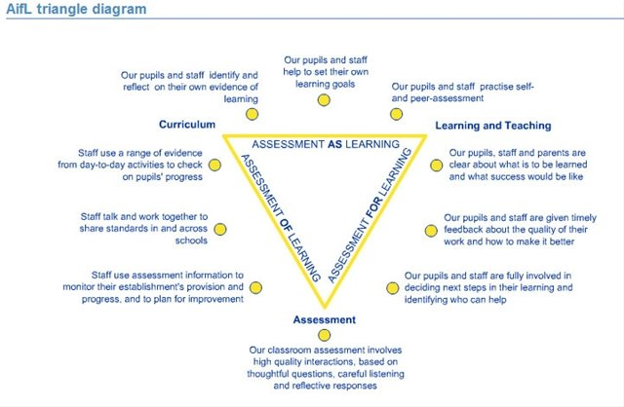

**Under Three’s**

**“**

**“**

*It is during our very earliest years and even pre-birth that a*

*large part of the pattern for our future adult life is set.*

*The Scottish Government, National Outcome for Children*

*http://www.scotland.gov.uk/About/Performance/scotPerforms/outcome/children*

Glasgow City Council’s aim is that all services to children and families, during the earliest years of a child’s life, are committed to ensuring that all children have the best possible start in life. Every child has the right to a positive start where they can be nurtured to develop “…a capacity to love, empathy, respect, resilience, positive relationships and the chance to succeed”.

We strive to provide an enriched learning environment which meets the need of each individual child through [the Pre-Birth to Three](http://www.educationscotland.gov.uk/earlyyears/prebirthtothree/nationalguidance/index.asp) document. The children will take part in a wide variety of experiences covering five curricular headings Literacy, Health and Wellbeing Emotional, Social and Personal Wellbeing, Health and Wellbeing Movement and Co-ordination, Numeracy and Mathematics and Curiosity.

The under three’s planning has four key principles which form the basis of this guidance:

* The Rights of the Child
* Relationships,
* Responsive Care
* Respect

All our staff are aware that these principles are linked to each other.

Our staff regularly record and share significant observations along with selecting planned learning outcomes that meet the needs of each individual child.

*At Festival Park Day Nursery we work in partnership with parents/carers in sharing information about their child with each child having their own individual profile and also through our home links sheets/information sheets. Please see staff if you require any further information.*

**MC900287313[1]Useful Addresses**

Maureen McKenna: Executive Director of Education

Glasgow City Council

Education Services

City Chambers

40 John Street

Merchant City

GLASGOW

G1 1JL

Social Care and Social Work Improvement Scotland

4th Floor

No 1 Smithshills Street

Paisley

PA1 1EB

Tel no: 0141-843-4230

**Suggestions and Complaints**

We are always anxious to maintain and improve our service. If you have any suggestions to make about the service, please contact the Head of Establishment in the first instance. Similarly, if you want to complain about us, and feel that your complaint has not been satisfactorily resolved with the Establishment Head you can contact Customer Liaison Unit at:

Education Services Customer Liaison Unit

Glasgow City Council

City Chambers

40 John Street

Merchant City

GLASGOW

G1 1JL

Telephone: 0141-287-5384

Email – [education@glasgow.gov.uk](mailto:education@glasgow.gov.uk)

For more information regarding our complaints procedure, please follow this link: glasgow.gov.uk/index.aspx?articleid=16133

**Public Transport Links**

The area has frequent public transport links:

Kinning Park & Cessnock Underground Station

First Bus no. 9, 10, 89, 90 (to Paisley road west)

McGills 38 (to Paisley Road West)

Arriva 23, 23A, 26 (Pacific Drive)

Stagecoach x19

***Important*:** *Although this information is correct at time of printing, there could be changes affecting any of the matters dealt with in the document.*

*- Before the commencement or during the course of the establishment year*

*- In relation to subsequent establishment years*