Castlemilk Family Learning Centre

Handbook

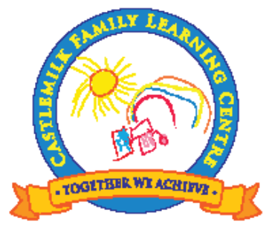


Within Castlemilk Family Learning Centre, we believe that every child is special with individual needs and will work together with parents/carers and other agencies as a team to provide a welcome, happy, safe and stimulating environment where all are encouraged to meet their full potential

Our Vision

Establishment Aims

In our establishment we aim to offer the highest quality service.

- Provide a welcoming, safe and secure environment for all stake holders.
- Provide a range of opportunities for children and their families to learn and develop together in a rich and stimulating environment.
- Meet the needs of individual children by using assessment, observation and planning effectively.
- Promote an ethos of success by celebrating staff, children and families achievements.
- Embrace Curriculum for Excellence and Birth to Three/Realising the Ambition to enable all children to become successful learners, confident individuals, responsible citizens and effective contributors to support them on their journey for life long learning.
- Maintain our existing strong links within the local community and continue to work in partnership with other agencies.

Castlemilk Family Learning Centre

I would like to welcome you to Castlemilk Family Learning Centre and hope you find the information in our handbook useful. We hope that this will answer any questions you may have and give you a snapshot of our service.

Within our centre we aim to work closely with all our families and value parents/carers views or suggestions. We are an integral part of the local community and engage in many local initiatives.

Eileen Pollock
Head of Centre

Staff

Senior Leadership Team
Eileen Pollock | Head of Centre
Stephanie Glen | Depute Head of Centre
Kelly Sloan | Team Leader
Hayley Clark | Lead Practitioner of Attainment (LPA)
Clerical Team
Helen Dennis | Clerical Officer (Monday-Wednesday)
Jacqueline O’Neil | Clerical Officer (Thursday & Friday)
Baby Room Bubble
Anne Geddes | Tiny Bubbles
Joanna Waugh | Tiny Bubbles
Lisa Moran | Tiny Bubbles (P/T – T/T)
Margaret Marshall | Tiny Bubbles (P/T – T/T)
Toddler Room Bubble
Tricia Viola | Busy Bear Room
Lynne Sweet | Busy Bear Room
Maureen Henderson | Busy Bear Room
Nicola Galgani | Busy Bear Room (T/T)
Vikki Steven | Busy Bear Room (P/T)
Sadif Bashir | Busy Bear Room (P/T – T/T))
Louise Robertson | Busy Bear Room (SFLW)
Green Bubble
Johan Crampsie | Sunshine Room
Angela Snell | Sunshine Room
Julie Bell | Sunshine Room
Christine Dalgleish | Sunshine Room (PT)
Megan Docherty | Sunshine Room (PT)
Michelle Mulholland | Sunshine Room (SFLW)
Purple Bubble
Joanne MacLean | Sunshine Room
Lisa McMullen | Sunshine Room
Karen Kirke | Sunshine Room
Brenda McGinley | Sunshine Room (TT)
Lorraine Tannock | Sunshine Room (SFLW)
Support Staff
Isabel Coyne | Facility Officer
Janey Gavigan | Lunch Support
Charlene Nicoll | Day Cleaner
Susan Simpson | Evening Cleaner


General Information
Opening Times  The Nursery opening hours are:  8.00am - 6.00pm  The session times are:  Morning: 8.00am – 12.45pm  Afternoon: 1.00pm – 5.45pm  Fulltime: Session times vary  Admission Policy  All nursery places are allocated in line with the Council’s Admission Policy.  The Admission Panel will meet 3 times a year.  The Panel consists of the heads of centres from the local nurseries in the area as well as  Representatives from other agencies such as health visitors.  A leaflet outlining the Council’s policy for admissions is available on request.  The centre is registered to take:  12 children 0-2yrs  25 children 2-3yrs  32 children 3-5yrs  In various patterns of attendance  Register of Applicants    A register of all applicants will be kept by the Head of Establishment and the information contained in the applications will be considered by the admissions panel to assist in the allocation of places.  Please note that the length of time a child’s name has been on the register will not affect the child’s priority for admission. Children may be put on the waiting list at any age by completing the appropriate application form.  Parent/carers can ask to see their application form at any time. If circumstances change which affect the application please speak to the Head of Establishment.  When a place becomes available notification will be sent out with a starting date and on that occasion the necessary enrolment/charges forms will be completed.  Attendance  Regular attendance at nursery is important as children may miss out on certain experiences if they have frequent absences.   | Address  Castlemilk Family Learning Centre  20 Ardencraig Road  Castlemilk  Glasgow  G45 0VV  Tel No: 0141-634-2007  Nursery Charges  Charges for 2021-2022 sessions are as follows:  Hourly Rate £3.00 per hour  Low Income Rate £1.00 per hour  College/University £4.00 per hour  2 children at nursery £3.00 per hour (1st child)  £2.20 per hour (2nd child)  3 children at nursery £1.70 per hour (3rd child)  Children from out with Glasgow £4.00 per hour  Lunch £1.52  Snacks £0.26 per snack  Children who are 3 years of age and over are provided with 1140 hours per year (30 hours per week).  Children who are 2 years of age can also qualify for 1140 hours per year free if parents are on certain benefits.  Charges and methods of payment will be explained to you when you are offered a place for your child.  The nursery is open every weekday except Public Holidays and staff In-Service Training Days.  Dates in bold are for term time children and staff only.  Term - August 2021 - June 2022  September Weekend – Friday 24th and Monday 27th September 2021  October Week – Monday 11th to Friday 15th October 2021  Christmas / New Year – Thursday 23rd December 2021 to Tuesday 4th January 2022 (Inclusive)  Mid-term – Monday 14th & Tuesday 15th February 2022  Easter – Monday 4th - Monday 18th April 2022 (Inclusive)  (Good Friday – 15th April 2022)  (Easter Monday – 18th April 2022)  May Day – Monday 2nd May 2022  Friday 27th & Monday 30th May 2022  Summer break – Friday 24th June 2022  In Service days  Thursday 12th & Friday 13th August 2021  Friday 8th October 2021  Wednesday 16th February 2022  Thursday 5th May 2022  The building will be closed to all children and families on the above days.


How we promote Learning

Throughout the nursery we value play as the best way for your
child to learn, develop and reach their full potential.

In the nursery the children are offered many opportunities
to explore experiment and research their surroundings
which will help them become curious, ambitious and enthusiastic learners.

We plan using Curriculum for Excellence documentation in our 3-5 playroom where;

“Children learn by doing, thinking, exploring, through high quality interactions, interventions and relationships, founded on children’s interests and abilities across a variety of contexts. All combining to building the four capacities for each child”

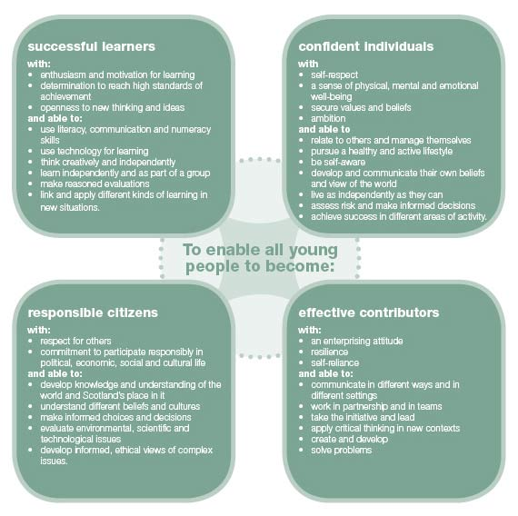
Scottish Executive 2007

Non denominational policy of the nursery

The nursery is non-denominational. We respect and welcome children and parents of all religions, faith and beliefs.

Our equal opportunities policy

All pre-five services should reflect the council’s equal opportunities policies and be anti-racist, anti-sexist, multi-cultural and recognise the rights of both

Curriculum For Excellence Overview

“Bringing learning to life and life to learning”

“Curriculum for Excellence aims to achieve a transformation in education in Scotland by providing a coherent, more flexible and enriched curriculum from 3-18, firmly focused on the needs of the child and young person and designed to enable them to develop the four capacities.”

(Building the Curriculum 3, Scottish Executive)

Planning

In our three to five year old playroom children access the curriculum through active learning and purposeful play. We follow the Scottish Executive’s Curriculum for Excellence 3-18 this places the child firmly at the centre of learning.

Staff provide many learning opportunities both indoors and out and make full use of our local facilities within our community to support children’s learning.

Staff consult with the children on a daily basis to find out what they would like to learn about and to explore ways of developing children’s personal interests. Staff discuss experiences and outcomes that will support the children’s learning through a variety of topics that the children have noted interest in.

We involve parent/carers in their children’s learning journey through Seesaw and Home Links. Staff record children’s work and their comments using the seesaw online learning journals, learning walls within the playrooms demonstrate the learning and skills they have achieved.

Within the playroom we have a wall of achievement that celebrates children’s success this will help the children develop into successful learners, confident individuals, responsible citizens and effective contributors.

Assessment

Assessment is an on-going process; staff continually observe the children in a wide range of situations by looking at what they say, do and demonstrate through play.

Observations, photographs, videos and examples of children’s work are used to support assessment and this provides valuable information and evidence of children’s progress and learning journey. Children are encouraged to evaluate their own work and share their skills with others. Staff praise and encourage the children which helps build children’s self esteem and confidence this is essential in our positive learning environment.

You will have opportunities on a daily basis to ask your child’s key worker how your child is progressing. If you would like to raise any concern’s about your child’s development please speak to the key worker and they will seek support from the management team if necessary.

Nursery/Primary Transition

A nursery to primary transition document will be completed in May and discussed with you prior to sending to your child’s school.
In the transition booklet the children will briefly describe who they are. Staff will then record the children’s learning and development through the eight experiences listed below through the Early Level of Curriculum for Excellence;

- Expressive Arts
- Health and Wellbeing
- Language and Literacy
- Mathematics
- Religious and Moral Education
- Sciences
- Social Studies
- Technologies

School induction days will be organised through your child’s own school, however staff will visit your child’s school with them for a look around and to take photographs to share with their peers. We have found this to be a success in the past and helps children share experiences of their school with friends and family.

Curriculum For Excellence learning Wheel

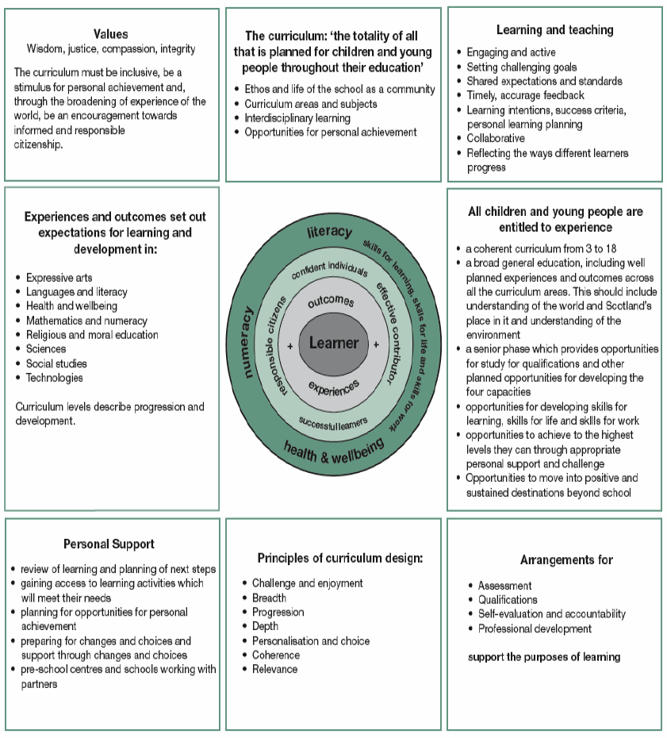

Arrival and Collection of Children  It is expected that a responsible adult will bring a child to and from the nursery.  In the interest of your child’s safety you should inform a member of staff if your child is to be collected by someone not known to the management team or staff members.  This avoids difficult situations when a child cannot be allowed to leave with an adult who is a stranger to the staff.   | Insurance    Sometimes children like to bring something special or new to nursery for their friends to see. However parent/carers should ensure that valuable items are not left at nursery, particularly as the authority has no insurance to cover the loss of such personal items.  
Excursions and Consent Forms  When outings or excursions for children are planned, the Head of Establishment or a member of staff will advise you in advance. You will be asked to complete consent forms which give permission for your child’s participation. Please note that children cannot take part in outings unless completed consent forms have been submitted by their parent/guardian.   | Suitable Clothing  Children have the best fun when they are doing messy work. We will always try to make sure they wear aprons but accidents happen so please dress your child in suitable clothes. We have a nursery uniform; this can be purchased by speaking to the office staff. Due to the Covid 19 pandemic, it is vital we have a spare set of clothing which can be kept at their peg in nursery. We cannot use/share clothing due to infection control procedures. Please, also make sure that your child has suitable outdoor clothing every day; this will enable them to take part in outdoor play or trips.  
Emergency Contacts  Parent/carers are asked where possible to provide the establishment with the names, addresses and telephone numbers of two contact persons for use in an emergency.  You are also asked to keep the nursery up-to-date with any changes in this information.   | Emergency Closure Arrangements  The nursery will be open on the time already outlined, but on some occasions circumstances arise which mean the nursery has to close.  This can be due to numerous problems such as severe weather, power failures or difficulties with water supply. If this happens, we will do all we can to let you know about the details of closure and re-opening.    We may keep in touch by telephone, email and Seesaw

Medication  If your child is in need of medication during their time at nursery you should discuss his/her requirements with a member of management. Only some prescribed medication will be administered by staff and you will be required to fill in a medicine form which authorises nursery staff to administer the medicine to your child. The staff will give you the necessary form to complete.  Your child’s medication must be clearly marked with their name and the dose of medication required by the doctor or pharmacy.  The nursery is unable to administer un-prescribed medication.  Toy Fund  We ask that all parent/carers pay £1.00 per week per child; this will pay for parties, outings, birthday and Christmas presents and any other treats and social events organised within the nursery. | If Your Child Becomes Ill    The establishment would welcome a telephone call if your child is not able to attend nursery on a particular day.  If your child becomes ill while at nursery he/she will be made as comfortable as possible whilst every attempt is made to contact you so that you can take your child home.  In the case of an illness or accident of a serious nature, your child will be taken to hospital and you will be advised to join your child there.  Please ensure your emergency contacts and telephone numbers are always up-to-date.
Minor Accidents and Upsets  These will be dealt with by the staff and you will be told about the accident/incident and asked to sign an accident form when you return to collect your child. | Visit to the Centre by Medical Staff  Children in their pre school year will be offered visual screening in nursery. You will be told the date of the visit and be asked for permission.

SAFETY IN THE SUN

It is important that your child is protected from the sun;

When the sunnier weather arrives, we ask that you provide a sun hat and pay £1.00; this allows the centre to purchase sun cream which can be used for your child. The only difference to this would be, if your child had an allergy; we would then ask you to supply a specific sun cream suitable for their skin.


Smile and Be Healthy

The nursery participates in the Smile and Be Healthy Programme. All children will get the opportunity to brush their teeth (daily) while attending the nursery. This encourages children to have good oral hygiene and understanding about their health and wellbeing.

Children will also get offered a pack (toothbrush and paste) twice a year.

All staff have been trained by qualified professionals and received certificates for completing this.

Meals



Lunch and snacks will be provided for all 3 year olds, 4 year olds and eligible 2 year old children.

Snack and the Promotion of Healthy Eating


A variety of snacks are provided for the children in the morning and the afternoon.

A menu is displayed for parents to see what their children are being offered for lunch.

Please inform the Head of Establishment if your child requires a special diet for medical or religious reasons.

No smoking Policy

Smoking is not permitted within the nursery premises or in the school grounds.

Anyone wishing to smoke must be outside the school gates on Ardencraig Rd.

Child Welfare and Safety

All educational establishments and services must take positive steps to help children and young people protect themselves by ensuring that programmes of health and personal safety are central to the curriculum and should have in place a curriculum that ensures that children/ young people have a clear understanding of the difference between appropriate and inappropriate behaviour on the part of another person, no matter who.

As with other areas of the curriculum; you will be kept informed of the health and personal safety programme for your child/ young person’s establishment.

Educational establishments and services must create and maintain a positive ethos and climate which actively promotes children and young people’s welfare and a safe environment by:

- Ensuring that children and young people are respected and listened to
- Ensuring that programmes of health and personal safety are central to the curriculum
- Ensuring that staff are aware of child welfare & safety and protection issues and procedures
- Establishing and maintaining close working relationships and arrangements with all other agencies to make sure that professionals collaborate effectively in protecting children and young people

Should any member of staff have concerns regarding the welfare or safety of any child or young person they must report these concerns to the head of the establishment. The Head, or the person deputising for the head, after judging that there may be grounds for concern regarding the welfare or safety of any child or young person must then immediately advise social work services of these concerns.

The Acorn Room

Within our centre we already create a safe, stimulating and nurturing environment and our nurture room builds on this foundation.

Nurture groups have been in existence since the 1970’s with the main focus being on children’s social and emotional development.

The Acorn Room works on the foundation of the six nurturing principles, which are embedded within our centre.

1. Children’s learning is understood developmentally
2. A safe base for children to be in
3. Nurture is important for the development of wellbeing
4. Language is understood as a vital means of communication
5. All behaviour is communication
6. Transitions are significant in the lives of children

The Acorn Room operates four sessions per week, we establish a consistent approach where trust and relationships can develop in a safe environment.

The Acorn Room has a maximum of four children; they follow a daily and weekly plan to support and develop their emotional and social skills.

Our Objectives

As a nursery community we are all committed to nurture and form an inclusive approach to understanding nurture and its purpose. In Glasgow we listen to children, as they have the right to be consulted in matters affecting them and have their views considered. Nurture sets individual targets for every child. This step by step process will follow a pathway of discussion and planning with the child and their family to establish clear and manageable expectations.

Success Criteria

- To meet the individual needs of the children.
- For children to feel safe.
- For children to be given the support, care and time they need to achieve their own individual targets
- For children to learn how to manage their emotions throughout a wide range of social experiences to prepare them with the skills they will require in later life.
- To make parents feel included and want to be part of their child’s nurture journey.

Supporting Children  If a child shows any signs that they may need additional support (speech, hearing etc). The head of centre will discuss with the parent possible ways in which we can help and will ask their consent before seeking input from outside agencies.  Parent/carers can of course refer their child themselves via their health visitor or GP.  Children with specific educational needs are integrated into the playroom with the other children and will receive support to enable them to participate fully in all activities.  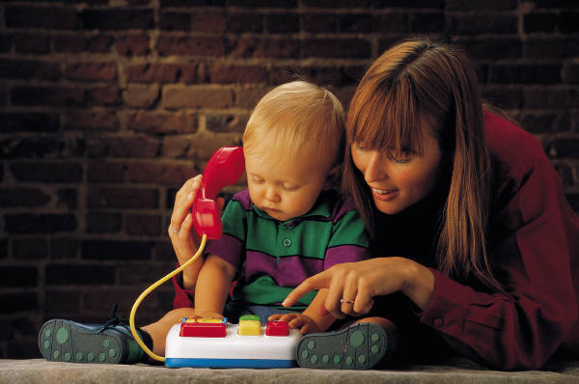 |  | Working Together to Support Learning    Parent/carers are encouraged to discuss their child’s progress with their keyworker; their views and comments are valued by staff.  Information provided by the parents about their child’s home life, experiences and overall development is vital as it enables staff to ensure that we meet each child’s individual needs while complimenting and extending their knowledge which the child has gained at home.

Learning Journals

On starting the nursery you will be asked to complete a home to nursery transition and an individual care plan. This will help us to get to know your child, for example, likes/dislikes, eating and sleeping habits.

During your child’s time at the nursery an online profile containing photos and evidence of your child’s learning experiences will be compiled, using a program called Seesaw. Seesaw is an online program for tracking children’s learning. This program has an online app that parents can access from any online device.

When your child leaves the nursery we will compile a transition document which will be forwarded on to their new school. You will be consulted on this report and asked to contribute any comments along with your child.

Staff will keep you up to date with your child’s progress, please feel free to speak to your child’s keyworker or a member of the management team regarding any concerns you have with your child’s learning at any time.

Parents/Carers Groups

Within Castlemilk Family Learning Centre we have always offered a variety of parents/carers groups. These groups have been run on different days and held at different times in order to ensure as many people can take part as possible. Covid has interrupted our ability to carry these out, but our aim is to offer these again; outdoors, if we have to in order to adhere to the guidelines in place at the time. We will notify you of these sessions/classes through Seesaw.

An example of some of the classes we have offered:

- Arts and crafts
- Cookery Classes
- Literacy and Numeracy Classes
- Triple P (Promoting Positive Parenting)
- Jewellery making
- Sewing classes
- Five to Thrive
- Families in Partnership
- Beauty Therapy

If there is a specific topic or class that you would like us to run please do not hesitate to ask and we will try and arrange this for you and the other parents.

Parental/carer Participation

We are always looking for parents/carers to come on board our parents group and fully participate in the life of the centre Please let us know if this is something you would be interested in.

Having parental/carer input is vital for the nursery as it gives the parents the opportunity to express their opinions, ideas and feelings.

All parents, carers, grand parents and service users are welcome to attend any of our groups.

The Establishment and the Community

We always aim to develop and extend links with other nurseries, schools and agencies within the local community. Creating these positive links allows us to offer advice to parent/carers about groups and other support available within the local area.

At nursery your child will be encouraged to develop and share their knowledge of the local community and take part in outings to libraries, access buses and trains, local wooded area and parks etc.

The nursery always welcomes the opportunity to take part in community events, the children enjoy events at the fire station, police station and COJAC centre. This helps the children gain familiarity of the area and the people who live and work in it.

We will ensure that any events/opportunities your child is part of is carried out in a Covid safe way.

Services within the Community

Social Work Department Castlemilk Health Centre
10 Ardencraig Road 71 Dougrie Drive
Glasgow G45 9US Glasgow G45 9AW


Tel No: 0141-276 5010 Tel No: 0141-531-8500/8585

Links with the Learning Community

Castlemilk Family Learning Centre is part of the Castlemilk Learning Community.

Together with other nurseries, primary schools and high schools in our Learning Community we meet on a regular basis. This allows us to share information and resources and helps to build positive relationships with other

Establishments.

Suggestions and Complaints

We are always keen to maintain and improve our service. If you have any suggestions to make about the service, please contact the Head of Centre.

If you have a complaint about any aspect of the service you may contact the Head of Centre; if you are not satisfied with the outcome of your discussion with the Head, you may wish to contact the Customer Liaison Officer.

A copy of the complaints procedure can be obtained from the office.

USEFUL ADDRESSES

Customer Liaison Officer
Education Services
City Chambers East
40 John Street
GLASGOW
G1 1JL

Tel No: 0141-287-5758

Care Inspectorate
60 Castle St,
Hamilton
ML3 6BU

Telephone number: 01698 897800

Lord Provost
Phillip Braat
Local Councillor
City Chambers
George Square
GLASGOW
G2 1DU

Tel No: 0141-221-6714

